d 

Evaluation of Deep Learning Models for Grocery Image Classification

By

Soh Zong Xian

TP053935

UC3F2301CS(DA)

A report submitted in partial fulfilment of the requirements of Asia Pacific University of Technology and Innovation for the degree of

B.Sc. (Hons) Computer Science specialism in Data Analytics

Supervised by Hema Latha Krishna Nair

2nd Marker: Dr. V Sivakumar

June-2021

Table of Contents

Table of Figures 4

Project Acknowledgement 7

TITLE: Evaluation of Deep Learning Model for Grocery Image Classification 9

CHAPTER 1: INTRODUCTION TO THE STUDY 9

1.1 Background of the project 9

1.2 Problem Statement 10

1.3 Rationale 11

1.4 Potential benefits 12

1.4.1 Tangible benefits 12

1.4.2 Intangible benefits 13

1.5 Target Users 13

1.6 Scope and objectives 13

1.6.1 Aim 13

1.6.2 Objectives 14

1.6.3 Deliverables – Functionality of the proposed system 14

1.6.4 Nature of the challenges 14

1.7 Overview of this project 15

1.8 Project Plan 16

CHAPTER 2: LITERATURE REVIEW 17

2.1 Introduction 17

2.2 Domain Research 18

2.2.1 Computer vision in Retail 18

2.2.2 Image Augmentation 19

2.2.3 Deep learning 23

2.2.4 Convolutional Neural Network 25

2.2.5 Industry Interview 29

2.2.6 Transfer learning 32

2.2.7 Normalization 32

2.3 Similar System/s 33

2.3.1 Comparison of Research papers 33

2.4 Summary 38

CHAPTER 3: TECHNICAL RESEARCH 39

3.1 Programming language chosen 39

3.1.1 Python 39

3.1.2 R 39

3.1.3 Why python 40

3.2 IDE (Interactive Development Environment) chosen 40

3.2.1 Jupyter Lab Python 41

3.2.2 Vs-Code 41

3.3 libraries chosen 42

3.3.1 Data Processing and Modelling 42

3.3.2 Data Visualization 43

3.3.3 Deployment 43

3.4 Operating System Chosen 44

3.4.1 Hardware requirements 44

3.4.2 Software requirements 44

3.5 Summary 44

CHAPTER 4: Chosen Methodology (CRISP-DM) 45

4.1 Introduction 45

4.2 Methods (CRISP-DM) 46

4.2.1 Phase 1: Business Understanding 46

4.2.2 Phase 2: Data Understanding 46

4.2.3 Phase 3: Data Preparations 47

4.2.4 Phase 4: Data Modelling 48

4.2.5 Phase 5: Testing and Evaluation 49

4.2.5.1 Evaluating results 50

4.2.5.2 Reviewing the process 50

4.2.6 Phase 6: Final Deliverable (Deployment) 50

4.3 Summary 51

CHAPTER 5: DATA ANALYSIS 52

5.1 Data preprocessing 52

5.1.1 Image data structuring 52

5.1.2 Image data processing 54

5.2 Model building 59

5.2.1 More Class 59

5.2.2 Less Class 65

5.3 Evaluation 66

5.4 Prototype deployment 66

5.5 Technical explanation 66

CHAPTER 6: RESULTS AND DISCUSSION 71

6.1 Tensorflow + keras (More class) 71

6.2 pyTorch (more class) 73

6.3 Fast AI (More class) 76

6.4 Tensorflow + Keras (less class) 76

6.5 pyTorch (less class) 77

6.6 Dashboard for the performance metrics and techniques 79

CHAPTER 7: CONCLUSIONS AND REFLECTIONS 80

7.1 Conclusion 80

7.2 Future Enhancements 82

7.3 Personal Reflection 82

References 84

Chapter 8: Appendices 86

8.1 Project log Sheets 86

8.2 PPF 90

8.3 PSF 92

8.4 Ethics form (Photostat copy) 96

8.5 Gantt Chart for FYP Semester 1 98

8.6 Gantt Chart for FYP Semester 2 98

8.7 Confidentiality Document 99

8.8 Library Cataloguing details 100

# Table of Figures

Figure 1 : Gantt Chart for fyp semester 1 16

Figure 2: Gantt chart for fyp semester 2 16

Figure 3 : Sample pre-augmented image 20

Figure 4: Sample Augmented image (Shift) 21

Figure 5:Sample Augmented image (Flip) 21

Figure 6: Sample Augmented Image (Rotation) 22

Figure 7:Sample Augmented Image (Zoom) 22

Figure 8:Neural Network Architecture 23

Figure 9: Neural Network Formula 24

Figure 10: Image Classification 24

Figure 11 : Convolutional Layer explanation (1) 26

Figure 12: Convolutional Layer Explanation (2) 26

Figure 13 : Downsampling illustration example 27

Figure 14 : CNN detailed architecture 27

Figure 15:Relu graph presentation Source : (Sharma, 2017) 28

Figure 16: Tanh graph representation Source: (Sharma, 2017) 29

Figure 17 : TanH formula Source: (Sharma, 2017) 29

Figure 18:Inductive transfer Sources: (Jason, 2017) 32

Figure 19:Batch normalization experimentation outcome. Sources: (Sergey Ioffe, 2015) 34

Figure 20 : Evaluation metrics’ for LCA 34

Figure 21:Evaluation metrics comparing different deep learning approaches 35

Figure 22:Normal CNN architecture 36

Figure 23 CNN layer with dilated core: 37

Figure 24 : Comparison between normal architecture and dilated CNN 37

Figure 25 : FCN architecture 38

Figure 26: FCN, Caps vs CNN 39

Figure 27: Crisp-DM 47

Figure 28:Image file renaming function 53

Figure 29:Renamed apple images 53

Figure 30:Renamed asparagus images 54

Figure 31:Function to reduce class 54

Figure 32:Function to expand classes 54

Figure 33: IF statement to determine which function to execute 55

Figure 34:Output 1 55

Figure 35:Output 2 55

Figure 36:Image loaded using datagen object 56

Figure 37:Augmented image visualized 56

Figure 38:Tf.data implementation 57

Figure 39:Parsed labels 57

Figure 40:Transformer object pyTorch 58

Figure 41:Transformed images 58

Figure 42:Both approached of data loading function (commented code is version 1) 59

Figure 43:Data normalization and augmentation 59

Figure 44:Output image 60

Figure 45: Keras base model architecture 60

Figure 46:Hyperparameter tuning using keras tuner 61

Figure 47:Random search technique is used for the hyperparameter tuning process 61

Figure 48: Transfer learning 62

Figure 49:pyTorch Model architecture 62

Figure 50:Forward Function 63

Figure 51:pyTorch optimizer params 63

Figure 52:Transfer learning model building pytorch 63

Figure 53:pyTorch hyperparameter tuning 64

Figure 54: Train Model function 64

Figure 55: Initialize models 65

Figure 56:Optimized training parameters 65

Figure 57: Transfer learning evaluation 66

Figure 58:FastAI transfer learning 66

Figure 59: Model loading 67

Figure 60: Model predict function 68

Figure 61:Async function to output prediction 68

Figure 62:Transformer object 68

Figure 63: Upload preview after uploaded image has been loaded 69

Figure 64: Passing uploaded image data to the approute function 69

Figure 65: Front UI of the web app 69

Figure 66: Model 1 output will be to predict generalized classes 70

Figure 67: Model 2 output will be to predict specific classes 70

Figure 68: power BI Dashboard 70

Figure 69: Accuracy by Techniques 71

Figure 70:Training time by techniques 71

Figure 71: Dashboard for transfer learning evaluation 71

Figure 72: Base CNN model architecture (Keras) 72

Figure 73: Result of tensorflow + keras (base) 72

Figure 74:Keras tuner outcome 72

Figure 75:Tensorflow + keras optimized 73

Figure 76: Transfer learning with keras 73

Figure 77: TF.data outcome 74

Figure 78:Results for base pyTorch 74

Figure 79:Results after optimizing activation function and perform data normalization 74

Figure 80: Results for data loader v2 75

Figure 81:Transfer learning 75

Figure 82: Transfer learning with data loading approach 2 75

Figure 83:Transfer learning optimized for accuracy 76

Figure 84: Transfer learning optimized for training time 76

Figure 85: Fast AI performance metrics 77

Figure 86: Base model for tensorflow + keras 77

Figure 87: Tensorflow + keras Transfer learning 78

Figure 88: Base model architecture result pyTorch 78

Figure 89: pyTorch with data loading v2 78

Figure 90: pyTorch TanH activation function result 79

Figure 91: pyTorch transfer learning 79

Figure 92: Transfer learning with data loading v2 79

Figure 93: Performance metrics dashboard for more class models/techniques 80

Figure 94:Performance metrics dashboard for less class models/techniques 80

Figure 95: Transfer learning analysis 81

Figure 96: Project Log Sheet 1 87

Figure 97: Project Log Sheet 2 88

Figure 98: Project LogSheet 3 89

Figure 99: Project logsheet 4&5 90

Figure 100: Project logsheet 6 90

Figure 101: PPF 1 91

Figure 102: PPF 2 92

Figure 103: PPF 3 92

Figure 104: PPF 4 93

Figure 105: PSF 1 93

Figure 106: PSF 2 94

Figure 107: PSF 3 94

Figure 108: PSF 4 95

Figure 109: PSF 5 95

Figure 110: PSF 6 95

Figure 111: PSF 7 96

Figure 112:PSF 8 96

Figure 113: PSF 9 97

Figure 114: Ethics Form 1 97

Figure 115: Ethics Form 2 98

Figure 116: Gantt Chart 99

# Project Acknowledgement

First and foremost, I would like to offer my thanks to my supervisor, Dr Hema for her continuous guidance as well as providing aid in the completion of my Bachelor’s Degree research and study. Her patience as well as guidance regarding industry requirements and communication are very useful and insightful, and will be immensely useful for my future career as well as personal growth. Not only that, the fact that she has made insightful comments on the earlier draft on my thesis, as well as allocating time to participate in the sync up sessions between me and the industry speaks volume about her commitment towards guiding me. I am grateful that I have her as my supervisor for my FYP thesis and her efforts that she has put towards guiding her students is commendable to say the least. Not only that, I would also like to thank Dr V Sivakumar for sharing his insightful perspective and knowledge in the area of computer vision with me, allowing me to obtain some additional perspective and direction regarding the techniques applied.

Besides that, I would also like to thank the FYP thesis committee, which consists of Mr Dhason Padmakumar as well as Dr Booma for their efforts in ensuring the submission and briefing process of the FYP are executed properly.

Furthermore, I would also like to express my thanks towards my lecturers, Dr Imran Medi as well as Mr Raheem Mafas for guiding me on the best practices and approaches on AI, deep learning as well as machine learning. Their useful insights have aided me in gaining a better understanding regarding machine learning as well as deep learning, which helped me in the execution and planning of this thesis.

In addition to that, special shout out to Dr.Booma in her deep learning techniques sharing during one of my modules, which allows me to further make improvement to my project research outcome. Also, special thanks to Dr Vazeer, as he introduced pyTorch deep learning implementation

Not only that, I am also grateful for all the lecturers that teaches the classes that I am part of during my studies. This is due to the fact that the knowledge that they have passed on to me are grateful towards my future career as well.

Thanks, towards Asia Pacific University of Innovation and Technology for providing me with the resources and support towards the completion of my studies.

Moreover, I thank my fellow classmates for the stimulating discussions regarding university subjects, assignments and potential FYP ideas as well as all the fun university life we had before the pandemic started. Special thanks to Thomas Clark for several late-night discussions and his knowledge sharing regarding computer vision and image recognition, which also contributes to aiding me in the execution plan of my FYP.

Most importantly, my heartfelt gratitude to my parents which supported me emotionally and financially throughout my university studies despite the pandemic.

# TITLE: Evaluation of Deep Learning Model for Grocery Image Classification

# CHAPTER 1: INTRODUCTION TO THE STUDY

## Background of the project

The retail industry is ongoing a rapid change in the midst of IR 4.0. The implementations of technologies such as IOT, machine learning, AI and big data analytics occurring in the marketplace in various domains have become a norm. In addition to the fact that the growth in the implementation of these technologies are accelerated due to a crisis, and it is observed that the innovation adaptation of many of these technologies in the retail industry. (Saik, 2020) According to a study by (McKinsey&Company, 2020), retail organizations that have successfully made the transition to digitalization, especially in the implementation of Computer Vision technology, will quickly capture the hearts of customers, therefore will bounce back at a much faster rate after the pandemic. This is basically boiled down to one aspect, which is the customer experience. Since the new normal is inevitable, where there are implementations of social distancing, digitalization becomes much important to bring convenience to the customers and this can be done using computer vision technology. Furthermore, the computer vision market is expected to grow in the next few years, according to the research from (MarketsAndMarkets, 2020), which further emphasises the need to perform implementation of computer vision in the retail industry in order for organizations to stay competitive.

Computer vision, is basically a subset of Artificial intelligence which allows machines and computers to understand the world of images. Using the implementation of deep learning in combination of the digital images, computers can accurately classify images, which is known as image classification. Since the retail market are filled with images of grocery items, and the images can be obtained easily through the shop cameras, it is not hard to obtain input data in the form of images. After these images are obtained, the data can be pre-processed and labelled in order to transform these input data into a usable format to be inputted into various deep learning models. The main objective of computer vision implementation, is usually to perform automation on what can a human eye perform. (Saik, 2020)

The main use case of computer vision includes the ability to provide stock visibility in order to heighten awareness of what is happening with the stock in the grocery store at all times. With computer vision technology being implemented in the camera system, automated stock tracking can be made possible with this implementation. The output of this implementation will therefore be resulted in reducing stock loss due to theft, which in return increases the return of investment over the long term. Not only that, if this implementation is refined with other technologies, keeping track of the amount of stock in the grocery stores at all time is also useful to predict and determine which stock is having lower amount than usual, and supplies can be added based on the observation by the computer vision. Not only that, the transition towards cashier less store is also due to the implementation of this technology. In this use case, computer vision is used to identify items that are going to be checked out that are on the conveyor belt. The implementation of this is basically to automate the customer service side of things, and by implementing this, the manual scanning of barcodes of individual items are automated as well, and this will enhance the experience of the customers, speed up the checkout process and also increase in security.

The study of this investigation report is to provide an analytics and evaluation approach to several deep learning implementations, approaches as well as benchmarking for image classification of grocery items. This project will be in line with researching for the best approach to implement computer vision in grocery stores, which the benchmarking outcome of low training time with respect to high accuracy and detection speed. This research also aims to be of use to the retail industry on their implementation approach decision of computer vision technology in their stores.

## Problem Statement

There are several concerns with grocery stores when thinking of implementing the computer vision/ image classification in their businesses. For instance, the sheer number of unique items in the grocery store can go up to 50,000, which can be daunting to pre-process these data for machine learning implementation. According to the research done by (Roser, 2019), the projection of the population from 1950 to 2100 will only go up, therefore the number of items in the grocery stores can only go up. Not only that, the number of unique items will also increase due to the constant innovation in the F&B industry market, creating more and more brands of grocery items. With that being said, the main issue for implementation of computer vision in this industry boils down to two fundamental concern, which is the amount of resources needed to maintain and train the deep learning model as well as the training time for these models to “learn” from these images to identify future images.

Organizations that are involved in the retail industry, that is looking to pivot into the implementation of the computer vision technology, will therefore need to understand the limitations, strengths and weaknesses on deep learning models, and the technical aspect of the implementation to determine the best approach that most suites their business use case.

## 1.3 Rationale

The main purpose of this project is to basically perform evaluation on different approaches to identify the best suitable, and direction to implement it in retail industry use cases. It is inevitable that computer vision and deep learning implementation have multiple challenges needed to be taken into consideration. If the challenges of implementation is not resolved, it may take days, even weeks to train the model before deployment and integration, which is extremely time consuming. Not to mention, the fact that the amount of time taken for the model to be trained will cause the inability to perform optimization for that particular model to increase the performance of its other metrics, For instance, the speed of image detection as well as the accuracy of the classification. Not only that, providing the required amount of image data will also be a daunting task as in order to obtain a high accuracy for the prediction deep learning model, a huge amount of image data for one particular label is needed to achieve a desired accuracy. This can only be possible if the model is able to achieve a high level of classification accuracy with a limited amount of image data as the input. In a nutshell, the implementation of computer vision/deep learning algorithm in the retail industry will be a success only if the amount of training time is low, while retaining its accuracy under a condition where limited dataset is provided.

Thus, this project will aim to provide:

* Understanding of different approaches and techniques to implement image classification for grocery images
* Develop several computer vision implementations using different approaches to detect grocery images.
* Data visualizations to showcase the performance metric of different computer vision approaches.

The evaluation outcome of these approaches will basically be useful for individuals in the retail industry and organizations to identify the approaches that most suitable for their implementation. This will basically reduce the cost of research and development on their side when trying to implement these solutions to their organizations.

## 1.4 Potential benefits

By researching on different computer vision approaches, and identifying their evaluation metric, retail organizations who are looking to implement computer vision in their business use cases will reap several benefits. These benefits are broken down into two parts, which are Tangible and Intangible benefits.

### 1.4.1 Tangible benefits

* Allows grocery stores to reduce the amount of resources needed to implement computer vision in various use cases.
* Obtain several computer vision execution approaches to be implemented in the organizations
* Improves operational efficiency by automating the human visual process as well as manual checkout process
* Provide insights on how various computer vision implementation approach can affect the evaluation metrics, which will be useful for future implementation and integration of other use cases.

### 1.4.2 Intangible benefits

* Allow grocery stores to improve customer retention by offering better customer satisfaction
* Lowers grocery item prices to stay competitive
* It helps reducing amount of resources needed to implement computer vision in stores, making it possible to reinvest that cash flow for more robust features to further serve customers.

## 1.5 Target Users

This project will be of use to several parties, mainly the technical teams and AI/Computer vision experts in a retail domain-based organization. The computer vision as well as deep learning engineers in the organization are basically the ones who are responsible for the implementation of image classification solutions within their stores. Not only that, after the implementation is done, there are still several phases which has to be taken into consideration, such as the hyperparameter tuning as well as the optimization of the deep learning model being deployed. This project will aid in these teams to cut short their research time, and have several different perspectives on the approaches to implement the solutions based on their use cases. The results of this project is supposed to determine the approach with a less training time, while maintaining the accuracy, thus making the approach ideal for implementation.

## 1.6 Scope and objectives

### 1.6.1 Aim

The aim of this project is to build a image classification inference algorithm to predict grocery items using several different methods and approaches, thus evaluating these approaches based on three different performance metrics, which are Image classification speed, model training time as well as accuracy.

### 1.6.2 Objectives

* To conduct research on several approaches on computer vision implementation for image classification
* To perform data pre-processing onto the collected image data to prepare them to be used as input model for the deep learning algorithm
* To implement image classification deep learning models using different approaches, tools and techniques
* To perform data visualization on the performance metric of these different approaches.

### 1.6.3 Deliverables – Functionality of the proposed system

Several key deliverables are as follows:

* Image pre-processing functions which includes image augmentation, conversion from image data to array data as well as image labelling
* Optimized deep learning models that are built for the pre-processed image data using several different approaches
* Evaluation performance metrics data visualization for benchmarking these different approaches
* Deployed optimized deep learning model into a simple, user friendly web application.

### 1.6.4 Nature of the challenges

The most fundamental challenge in the execution of this project is of course, research. This is due to the fact that research is the most important activity as it requires not only the knowledge and understanding of the potential use cases of computer vision and deep learning implementation in the retail industry, but also the knowledge regarding the technical aspects of these implementations as well. This section will be dedicated to mapping out the potential roadblocks that may be faced in order for this project to be a success. First and foremost, an understanding on the benefits of implementation of computer vision in the retail industry is important. This will include the understanding on what can computer vision do to aid individuals that are in this domain, as well as the value that brings to several relevant parties. Not only that, the effort in learning the technical aspects of implementing computer vision as well as the different approaches have to also be taken in to consideration during the research phase.

Furthermore, the reason why these technical know-hows is important is due to the fact that the image data pre-processing phase is directly correlated to the research phase. This is because images can’t be directly input into the deep learning model for image classification. Efforts have to be made in the data labelling and data pre-processing phase to convert these images into usable format. Not only that, techniques on how to perform optimization on deep learning models also have to be researched as this will aid in increasing the performance metrics of the outcome of the inference image classification model.

Above all that, the research onto building and optimizing deep learning models to make use of the pre-processed data will also be used to research on different approaches and techniques. This is to perform evaluation on the performance metrics on these different approaches. A detailed review will have to be carried out in order to further gather insights for the development and research process. Not only that, research also has to be done onto the techniques needed to perform data visualization on these evaluation metrics, ensuring that the visualization is easy for relevant parties to obtain insights, therefore making the decisions on which approach to go for.

Last but not least, documentation will also be a need to perform. This is due to the fact that the research and implementation outcome will be crucial to be documented as it can express the possible value that it may bring to relevant parties.

## 1.7 Overview of this project

Chapter one of this investigation report will basically be a document which describes the background of the project, and its problems statement to get a better understanding on what value can this project bring. In chapter 2, a detailed literature review will be performed and the relevant outcome of the domain and technical research will be documented. This includes an overview of the implementation of computer vision in the retail industry in section 2.1. Section 2.2 will thus be consisting on a simple introduction on the technical aspects on the implementation of computer vision, deep learning models, image classification and so on. In section 2.3, the understanding of similar systems for different approach to the image classification implementation will be documented as well. Not only that, in chapter 3, a discussion on the tools, techniques, programming languages, notebook as well as IDE and libraries being used for this project will be done. Furthermore, chapter 4 will be focusing on the project execution methodology, which documented the project phases, the tasks that have to be done in different processes as well as the relationships between these tasks. Finally, chapter 5 will be summarizing the evaluation results, and the identification of future work and implementation into several other use cases in the retail industry will be documented.

## 1.8 Project Plan

The project execution mapping of the final year project for semester 1.

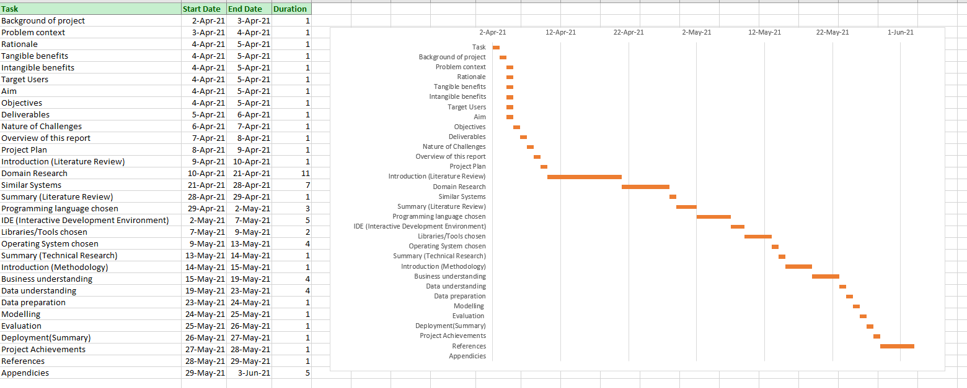

Figure 1 : Gantt Chart for fyp semester 1

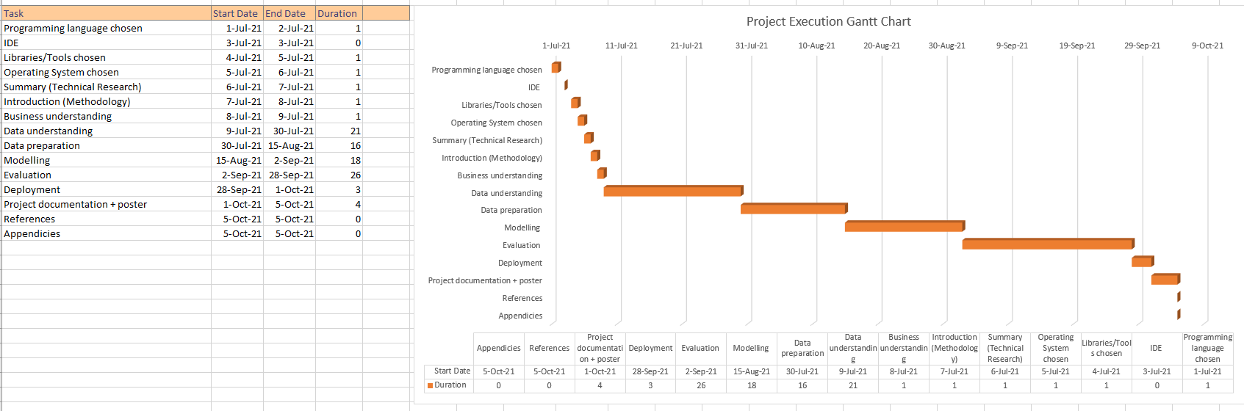

Figure : Gantt chart for fyp semester 2

Chapter one will mainly be focusing on the reasons, aims and objective of the project. This therefore will not take much time as the documentation is quite straightforward. Chapter 2 will be focusing on the domain research, literature review as well as the similar systems to the project. This will therefore take a lot of time as domain research is challenging in nature. Not only the technical research is needed, but also the industry research is needed. Chapter 3 will be about the tools and techniques used for this project. Since in chapter 2, the tools and techniques have been unknowingly been researched, chapter 3 will not take too much time as its just gaining deeper understanding and documenting it. Chapter 4 and 5 will be focusing on the execution flow of the project, which will also be slightly time consuming as specific details of the execution need to be mapped out.

# CHAPTER 2: LITERATURE REVIEW

## 2.1 Introduction

In this era where digitalization has become the norm for most companies, the world is making a shift towards the utilization of technologies to enhance efficiency in all things, for instance, manufacturing and automation. The main purpose of implementing computer vision in the retail industry is to automate redundant tasks which will reduce errors caused by humans. Not only that, computer vision is able to replace the visual aspect of the human’s job scope due to the fact that computer vision is basically the study of helping machines and cameras understand the information that is obtained by videos and images. There are several use cases within retails that are made possible by computer vision and image classification implementation such as computer vision self-checkout, computer vision powered robot assistance for security and many more. (Pixelplex, 2020)

This project research is about experimenting and researching on several image classification computer vision inference models to determine the best combinations of performance statistics and metrics for retail industry business use cases. In the field of computer vision and image classification, there are several approaches for implementations, however, there are some approaches that are more suitable compared to the others due to the nature of the retail industry, and the issues that they are facing.

In conclusion, the fundamental aspect of any research project is the appropriate understanding and review of research papers that are related to the technical and domain expertise that are required for the success of this project. This is to obtain a strong fundamental understanding of the knowledge required for the completion of this project. Purpose of this literature review is to perform analysis as well as evaluation on not only the various optimization methods that are related to building a computer vision inference models, but also various approaches on building it for the classification of grocery image items.

## 2.2 Domain Research

### 2.2.1 Computer vision in Retail

Given that in the current era, retail industries require much visual feedback as well as are consistently generating huge amounts of image data for that purpose, which will lead to consistent increasing interest in the implementation of this technology among this industry. This is caused by the advancement of computing hardware technology as well as the norm in utilizing big data to improve competitiveness and automation in the marketplace. The reason for so much computer vision use cases within the retail industry is due to the increase in demand for convenience and personalization in their grocery shopping experience. For instance, the ability to instantly scan an object without the need for a barcode scanner, but able to identify its prices will bring much convenience to them, therefore the retention rate of the customers will increase. Not only that, computer vision implementation is able to replace manual security monitoring systems in the store. For instance, if a real time computer vision implementation is implemented in the CCTV of the store, then it will be able to detect missing items from particular spots in real time, which will indicate either stolen items, or the need to restock. Multiple use cases, which will be discussed in this section, will basically improve on various inconvenience in the retail industry and potentially enhance both the experience of the customers as well as the employees in the store. (Koptelov, 2021)

First and foremost, the most common implementation of computer vision in the retail industry is self-checkout. This implementation has already been established one of the most important computer vision implementations within the brick and mortar stores. How this works is that it replaces the need for manual barcode scanners as computer vision powered cameras are able to identify products and the details of that product will be able to be obtained by the customers, not only this will reduce the hassle of employees to manually attach related barcodes to the items in the stores, but also improve the customer satisfaction while shopping for products. A more advanced version of this implementation will basically be the amazon’s just walk out system. This system basically uses a combination of IOT, cameras, sensors as well as deep learning and computer vision to allow store customers to just pick up the items, and walk out of the stores without the need to line up to make payment. The sensors and the cameras will detect missing items from the store with respect to that particular customer, and that customer will be automatically charged and the charges will automatically be deducted from the customers linked debit/credit card. (Amazon, 2021)

Furthermore, inventory management is also a potential use case in the retail industry that is related to computer vision. For instance, stock of the shelves can be monitored by using computer vision powered video cameras which viewing angles are directly on specific positions on the shelves. This implementation can have multiple benefits, which includes the monitoring of the shelves and consistently making sure that the shelves are fully stocked with relevant items. Not only that, if the shelves are unexpectedly empty, fraud and theft are able to be identified, hence enhancing security without the need for manual human security guard. This implementation is so powerful that if combined with real time data analytics, data driven decisions and positioning of stocks can be made by using association rule mining. (Melisa, 2021)

As shown from the above statement, all these use cases share one common roadblock in their implementation, which the amount of resources and data needed to train the model to be able to classify and identify future images. Not only that, the issue of the number of unique images needed to be identified in an average store are huge, which also means that even if the necessary data are managed to be obtained, the amount of time needed to train the model for prediction is going to take a long time. This therefore will be related to the other sub sections of this literature review.

### 2.2.2 Image Augmentation

Image augmentation is basically a technique that Is used to expand the size of the image training datasets. This is done generating images based on existing images, but with differing parameters such as different rotations, height and width shift, zooms and so on. The purpose of this technique is to increase the accuracy of the deep learning models to perform image classification with limited image datasets. This is due to the ability of this technique to create different variations of existing images in order to increase the generalization capability to new images. (ODSC - Open Data Science, 2019)

Example implementation of this technique applied on the image below will be as such:

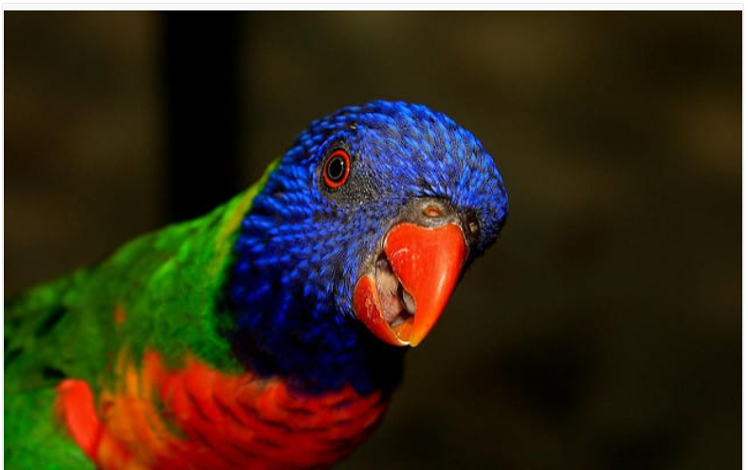

Figure 3 : Sample pre-augmented image

A range of techniques will be applied towards the augmented of the image above. For instance,

* Image shifts
* Image flips
* Image rotations
* Image zoom

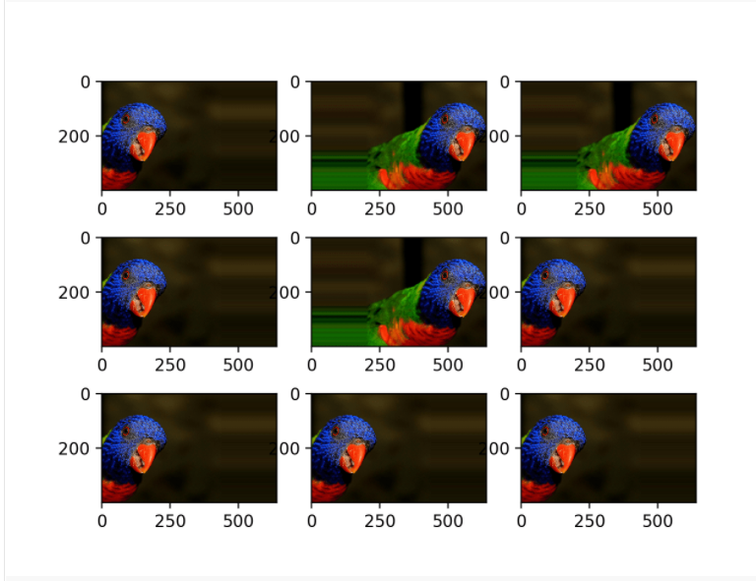

Figure 4: Sample Augmented image (Shift)

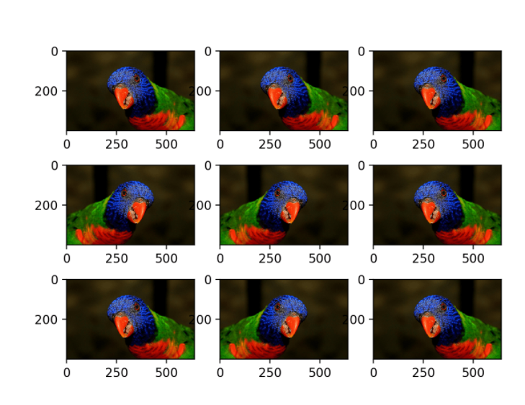

Figure 5:Sample Augmented image (Flip)

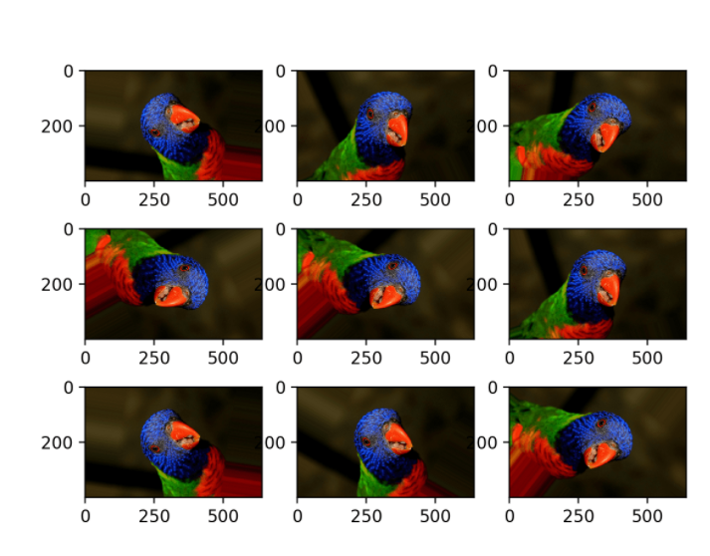

Figure 6: Sample Augmented Image (Rotation)

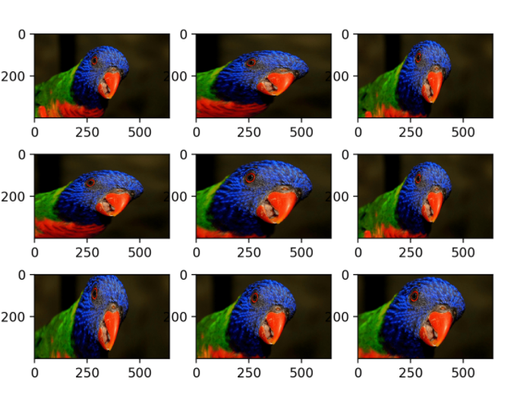

Figure 7:Sample Augmented Image (Zoom)

As shown in the illustrations above, there are many variations that are generated by using the image augmentation technique, and multiple different images are generated with only one images.

### 2.2.3 Deep learning

Deep learning is basically a machine learning technique that enables machines to learn by examples. How this differs from machine learning is the fact that machine learning has involvement with mathematical equations and requires in most cases, domain specific feature engineering to increase its accuracy. This will work in datasets that contains columns such as, category, age group, sales amount and so on, where the datatype is audible, and is able to perform mathematical correlation. For instance, linear regression, a technique in machine learning is able to predict accurately the house pricing based on previous house pricing data by inferring the weights of other features such as location and square foot. Deep learning uses neural network whereby it is able to predict new data points based on previous data points by identifying its patterns and learning by example. (Works, 2020) Applications for deep learning Is usually on datasets such as images and sounds. How this works is that the neural network is able to identify common features between the image training datasets and use this information to perform image classification and detection on future images as the output. By extracting features of the labelled image data, and inputting them into several hidden layers, the output is determined by the neural network formula in the illustration below.

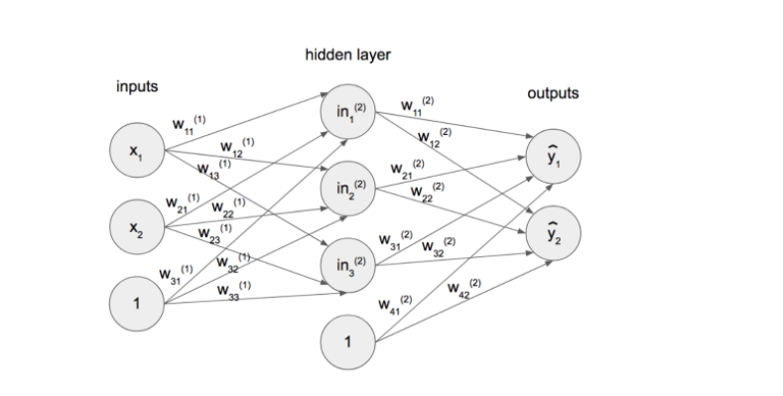

Figure 8:Neural Network Architecture

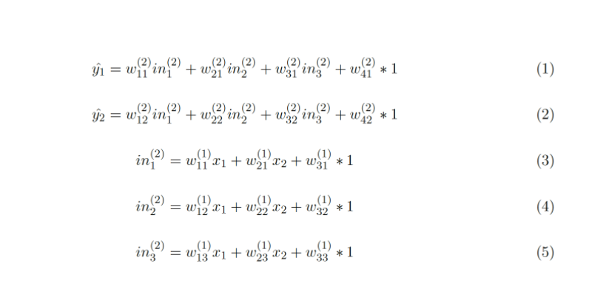

Figure 9: Neural Network Formula

In the formula above, the in1, in 2 and in3, are basically represents the hidden network. These hidden networks will basically be computed with the X1 and X2 which represents the input layers. The w’s in the equations are the weights within the neural network, and is determined by the dataset that is inputted. Finally, the output layer will be computed using the combinations of all these equations, and the Y1 and Y2 will be computed as the output. In the end, an illustration of how deep learning and neural network works for classifying images is below.

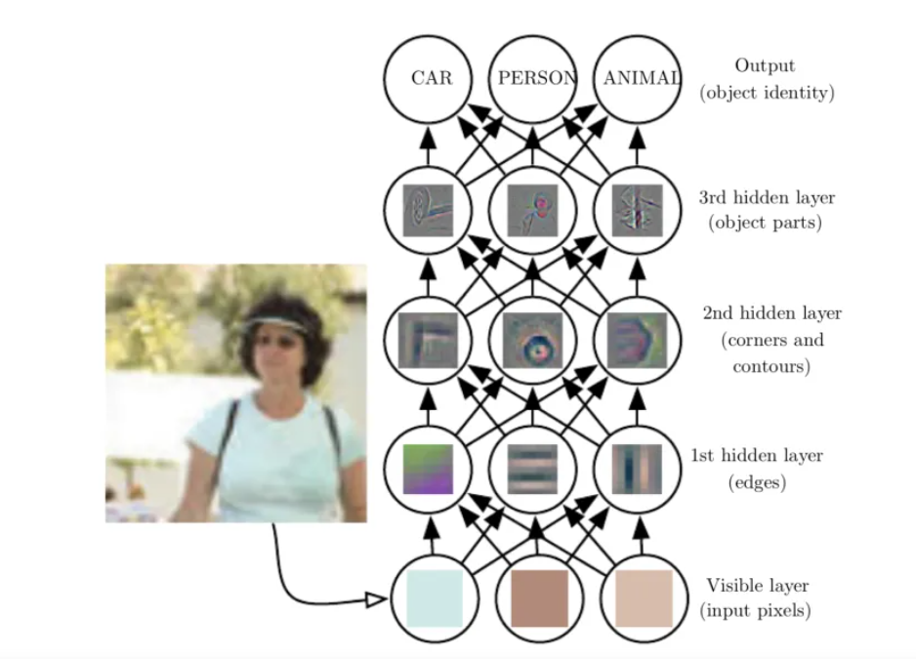

Figure 10: Image Classification

Deep learning engineers will consistently configure the hyperparameters and number of layers that is connecting the output of different layers onto different others. This will be based on the nature of the image datasets, the use cases as well as the performance metrics that is required to be focused on. For instance, in the retail industry, the number of unique items and classes are huge, therefore the priority lies within decreasing the model training time as well as increasing accuracy with limited amounts of image data.

### 2.2.4 Convolutional Neural Network

Convolutional Neural Network, in short CNN, are neural network models focused on classifying images as well as perform object detection based on similarity. CNN are powering many use cases in computer vision and image classification, and therefore have applications such as self-driving cars, face recognition medical diagnosis, and in this case, grocery image classification. How convolutional network works is that they take images that are converted into a matrix of numbers, called tensors. Tensors are basically a 4-dimensional list of numbers. There are several components within a convolutional neural network, which are convolution layer, fully connected layer as well as max pooling/down sampling.

**Convolution layer:**

Convolutional layer works by computing and identifying the pixels in an image. However, the layer will not compute the entire image at once, but will compute portions of the pixel of the images, and multiplying it by filters(weights), and therefore compute the output for that portion of pixels. These portions will be moving from left to right, and how much it moves and computes depends on the number of convolutional layer as well as the hyperparameter tuning setting applied.

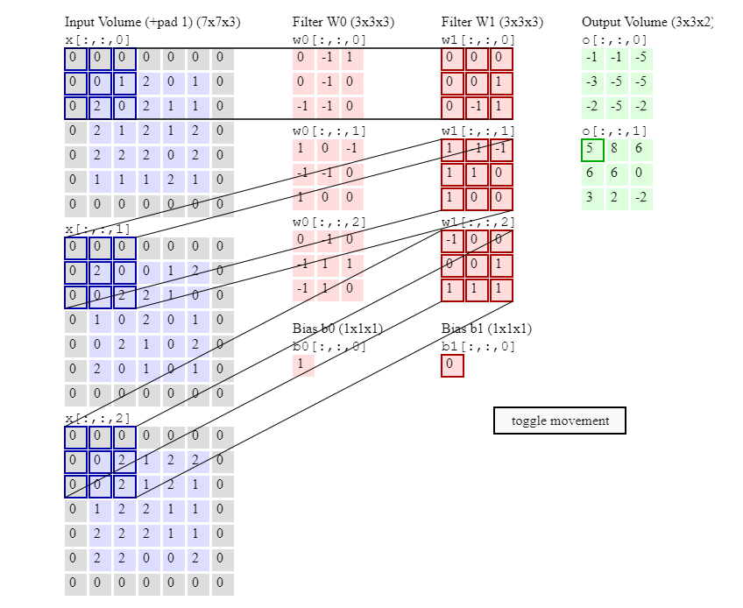

Figure 11 : Convolutional Layer explanation (1)

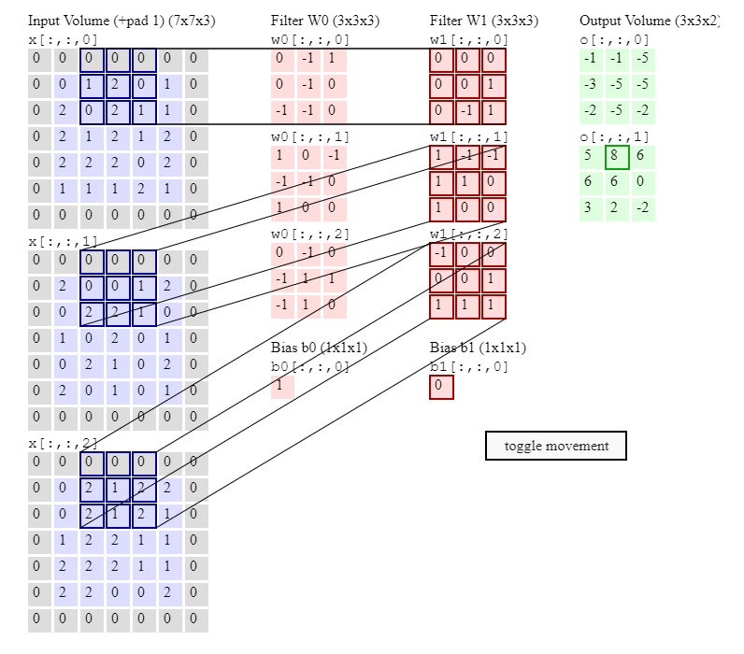

Figure 12: Convolutional Layer Explanation (2)

After the convolutional layer have extracted the features from the image tensors, these features will be then sent to the max pooling layer.

**Max Pooling/Down sampling Layer:**

In this process, the patches of output that are obtained from the convolutional layer, are further filtered. Max pooling layer will obtain the largest value from these patches of images, and then discards the rest of the information from the activation maps within the layers. (Karpathy, 2020)

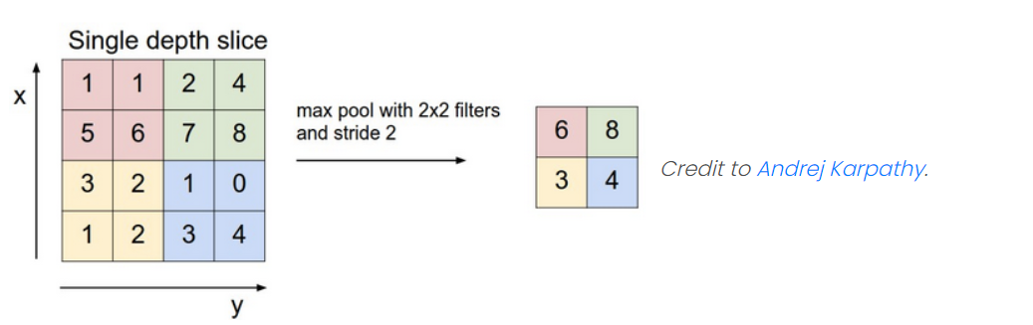

Figure 13 : Downsampling illustration example

In this layer, only the locations of significant correlations to the features, which are determined from the maximum value obtained from computation in previous layers are kept. This therefore provides an advantage due to the fact that lesser amount of storage and processing is required. The flow of the entire CNN model is as shown in the illustration below.

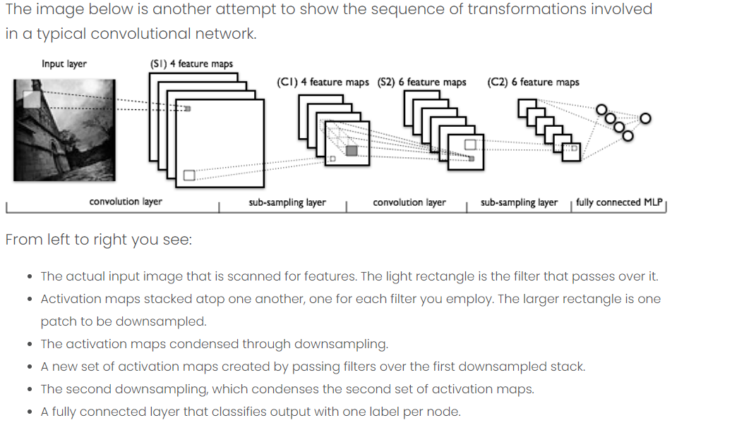

Figure 14 : CNN detailed architecture

**Activation Function:**

For the conv2D layers of the neural network architecture, 2 activation functions have been studied and selected for this project. First activation function would be Relu. This activation function is known to be the commonly used activation function for most of the neural network architecture.

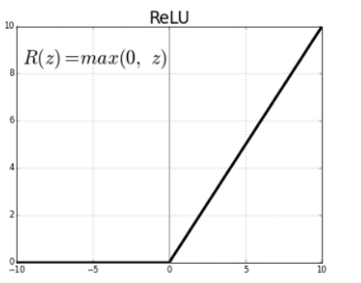

Figure 15:Relu graph presentation Source : (Sharma, 2017)

As shown in the illustration above, Relu activation function follows a formula which allows the computation of the tensors in a way where the negative values are automatically computed as 0. This activation function is therefore known as half rectified as the range of predictions are from 0 to infinity.

The next activation function that will be experimented for the Convolutional layer would be the tanh function.

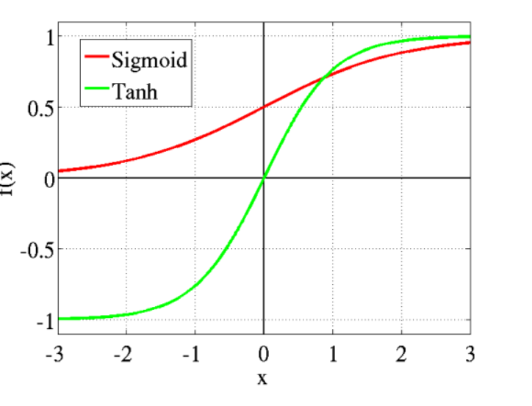

Figure 16: Tanh graph representation Source: (Sharma, 2017)



Figure 17 : TanH formula Source: (Sharma, 2017)

As shown in the above illustrations, the tanh activation function will map negative tensor outputs strongly. Therefore, unlike Relu activation function, the range for prediction for this activation function would be from -1 to 1. Hypothetically speaking, this activation function used by the layers would yield a better accuracy, as the image normalization will normalize the data from a range of [-1,1], which matches the prediction range of the tanh function.

### 2.2.5 Industry Interview

As this project is in collaboration with an organization that specializes in the retail industry. The purpose of these questions is to obtain more industry domain knowledge, and how the computer vision can provide value to the potential use cases in the retail industry. Not only that, more specific technical requirements for building the inference model, as well as the performance metrics to be researched and improved on will also be obtained from this interview.

1. What issues are the grocery industry currently facing, and why?

|  |
| --- |
| Ans: There are a lack of computer vision technology implemented in the grocery industry. |

Objective: **To obtain a general understanding of an actual industry issue within the consumer industry**

1. What are the issues that comes from hiring people for grocery stores?

|  |
| --- |
| Ans: Profit margins are always low due to the need for huge amounts of labor. |

Objective: **To understand what are the issues regarding the hiring and human resource to gauge the importance of the computer vision project.**

1. Are there a need for automation in the consumer industry? For example, to aid in self-checkout?

|  |  |
| --- | --- |
| Ans: Yes, image classification and recognition would be nice. |  |

Objective: **To obtain knowledge regarding the application of technology in the retail industry.**

1. Would a computer vision/image detection implementation benefit the consumer industry in grocery stores? If so, why?

|  |
| --- |
| Ans: Yes, image classification and recognition would be nice. |

Objective: **To understand the need of grocery stores to implement computer vision.**

1. What will be the potential goals and objectives for this implementation?

|  |
| --- |
| Ans: To perform some sort of automation in the grocery industry |

Objective: **To understand specific output of the computer vision project, and how the fyp project scope are able to aid in that direction.**

1. Who will benefit from the project? And why?

|  |
| --- |
| Ans: Consumers will benefit from convenience, the grocery industry will increase profit margins |

Objective: **To identify the target audience of the computer vision project implementation, and who will be influenced by it.**

1. What possible applications are there would be most beneficial to your client for computer vision implementation in their grocery store?

|  |
| --- |
| Ans: To be used in the self-checkout section. |

Objective: **To understand the tangible and intangible benefits of the computer vision project.**

1. Would a computer vision/image detection implementation benefit the consumer industry in grocery stores? If so, why?

|  |
| --- |
| Ans: Yes, some research implementation is needed to explore multiple directions of that implementation. |

Objective: **To make sure that the scope of the fyp matches the scope and requirements of the industry project.**

1. How many unique items are there in an average grocery store?

|  |
| --- |
| Ans: Around 50,000 items |

Objective: **To identify the specific technical requirements of the computer vision project.**

1. What are the potential challenges that will be faced during the implementation of computer vision in consumer industry?

|  |
| --- |
| Ans: The model training time, and the sheer amount of data needed. |

Objective: **To ensure that the execution plan of the project take into consideration of the potential challenges currently the consumer domain is facing.**

1. When evaluating a deep learning inference model, what evaluation metrics would you want to focus on? And why?

Ans: Model training time and accuracy.

|  |
| --- |
|  |

Objective: **To identify the performance metrics that are important for the client while researching and benchmarking computer vision model approaches.**

1. Would classifying different brands on items into one class type ok for the implementation, For instance, Maggi and Cintan instant noodles-> instant noodles?

|  |
| --- |
| Ans: Yes |

Objective: **To validate a potential method to implement the inference model.**

1. How will the implementation of computer vision help customers in the grocery store?

|  |
| --- |
| Ans: Not clear yet. |

Objective: **Get a final understanding of how the end product of the inference model (Fyp), is going to be used to be beneficial to the computer vision project that the client is working on.**

1. How will the inference model be implemented in your system?

|  |
| --- |
| Ans: It will be embedded in a live client server software. |

Objective: **Get a final understanding of how the end product of the inference model (Fyp), is going to be used to be beneficial to the computer vision project that the client is working on**

1. What type of charts will be preferred to visualize the outcome of the evaluation metrics?

|  |
| --- |
| Ans: As long as a clear dashboard is made, it doesn’t matter. |

Objective: **To identify the specific deliverables required as the output of the project.**

1. Will an individual from the industry be open to test the outcome of the inference model?

|  |
| --- |
| Ans: Not sure, will keep u updated when I am free. |

Objective: **To gain direct feedback for the outcome of the project.**

### 2.2.6 Transfer learning

This technique is a study within deep learning whereby a model which are trained using sets of data, are saved, then using it to be reused as a beginning point for a model to be trained for another task (Jason, 2017).

Transfer learning in a deep learning domain, is called inductive transfer. This is done by the scope of the prediction output for the trained model is narrowed down, matching it with the input and output data of a different, but related task.

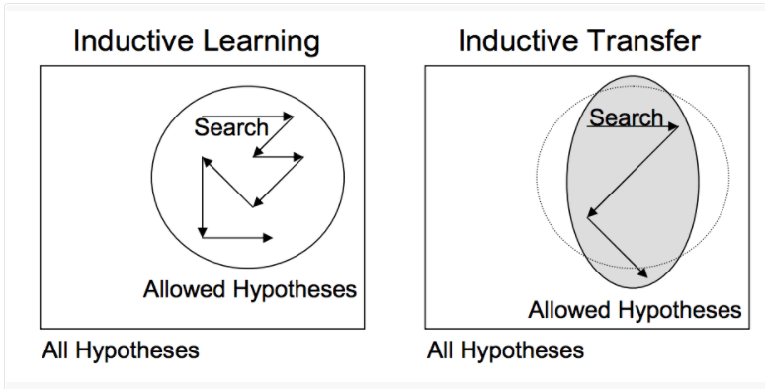

Figure 18:Inductive transfer Sources: (Jason, 2017)

Similarly, with both pytorch (Chilamkurthy, 2021) and TensorFlow library (AnalyticsIndianMag, 2021), to apply transfer learning follows almost the same concept. In both implementations, the networks within the pre-trained model are frozen, and only the input layer and output layers are unlocked. These layers are trained with the dataset and labels of the designated tasks. Fast AI however, automates the transfer learning process whereby the retraining of the top and bottom layers is not needed, and the API object can be just called to perform transfer learning.

### 2.2.7 Normalization

#### 2.2.7.1 Image normalization

From a machine learning project perspective, in the data preprocessing phase, data normalization techniques such as min max scalar as well as standard scalar is needed to ensure that the numerical is normalized, and the outliers will not affect the model accuracy as much. In image classification task, it is also possible to normalize the data, this technique is called image normalization. This ensures that the image input parameters, which is pixels in this case, has a similar, normalized distribution. This works similarly with data normalization in machine learning datasets, whereby data normalizations is applied on every pixel of the images, scaling the data to [0,1] or [-1,1]. This is done by subtraction of mean and a division of corresponding result by the standard deviation (Nikhil, 2017). Overall, this technique is known to reduce deep learning training time.

#### 2.2.7.2 Batch Normalization

A known issue for deep learning model training is that, the distribution of the input layers often changes during the model training. This is usually due to the fact that the parameters from the previous layer changes. This will therefore cause an increase in model training time as well as decreasing learning rates. A known technique to solve this issue is batch normalization, whereby allowing a higher training rate to be used while maintaining the training time. A paper regarding this, titled, Batch normalization: Accelerating Deep Network Training by reducing Internal Covariate Shift by (Sergey Ioffe, 2015), suggests that by applying this technique on any set of activations in the neural network architecture, this will enables a higher learning rate as well as regularizes the model, hence reducing the time taken for the model accuracy to reach 72% compared to a non-batch normalization architecture.

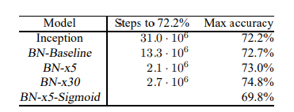

Figure 19:Batch normalization experimentation outcome. Sources: (Sergey Ioffe, 2015)

## 2.3 Similar System/s

### 2.3.1 Comparison of Research papers

The aim of this section is to do research on journal articles that have made similar techniques in the execution plan of this project. In this project, although going to be tackled at a different approach, some fundamental techniques will be applied, such as the image augmentation, as well as hyperparameter optimization for the CNN models.

A paper by (Srivastava, 2020) made use of deep learning techniques for image classification. This paper introduces a new neural network layer which adds consistency and accuracy to the prediction outcome. This layer is called Local-Concepts-Accumulation (LCA) and how this layer works is features are built for all possible local features that are obtained from an image and averaging these features. These features will then be fed to the output to increase the output accuracy. As shown from the illustration below, adding the LCA layers to several pre-trained models improves the accuracy of image classification.

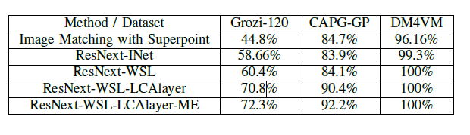

Figure 20 : Evaluation metrics’ for LCA

This technique could potentially be of use to the execution project as this might further increase the accuracy of the project without the need to increase the amount of image dataset needed. If the image dataset needed is not much, this can be a potentially promising effort in making the time taken for model training time to be reduced. This hypothesis has to be further experimented as the model training time is not mentioned in the research paper referred.

Besides this, there is another paper by (A.V. Bernstein1, 2018) which suggested reinforcement learning for image classification using visual features. In reinforcement learning, there will be a visual feature extracting systems that utilizes supervised learning algorithm, which will then be used to classify images as the output. Hence, the conversion of low-level pixels as input, will be transformed into high level information (classes of images). The theories from this conference proceedings highly correlates to the approach of this project, therefore can be further studied, and the fundamental techniques of this paper might be applied in the execution of the project.

A paper from (Yuchen Wei, 2020) have explored the challenges and techniques for image classification in retail products. This paper has researched on multiple techniques such as R-CNN, yolov2 as well as SSD techniques and comparing the accuracy and precision of these image classification algorithms. This paper has also addressed the issue of limited datasets by using image augmentation technique which proves that the current execution of the project is plausible and is on the right direction. Below are the benchmark results of that research paper.

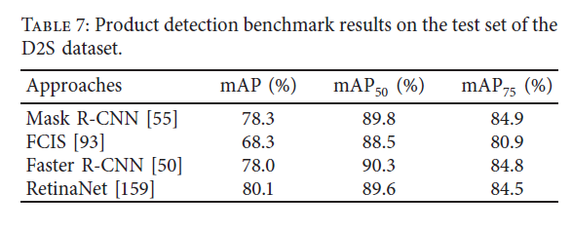

Figure 21:Evaluation metrics comparing different deep learning approaches

As shown from the benchmark results, the accuracy for CNN based algorithms yields the best accuracy result compared to the other techniques, therefore this project will only be focusing on optimizing CNN, and then build the inference model based on that using different approaches. Not only that, it is mentioned in the paper that the dataset used for this task does not really simulate the actual use case of the retail industry. This is due to the fact that the retail industry has over 50,000 unique items to be tested on, and the dataset tested does not reflect that. Not only that, the fundamental performance metrics that is needed for the retail industry use case is not covered in this research paper, which is the model training time. In conclusion, this project aims to focus on the model training time performance metrics, while retaining the accuracy of the algorithm in order to increase the relevancy of this project onto a more industrial use case. The study of techniques from this research paper will be much needed to make this project a success.

Furthermore, a paper by (XINYU LEI, 2019) suggested that stacking 2 dilated convolutional kernels, replacing the original convolutional layer will decrease training time as well as improve accuracy. Both illustrations below show the differences between a traditional CNN model and the dilated CNN model as well as the accuracy comparison between them.

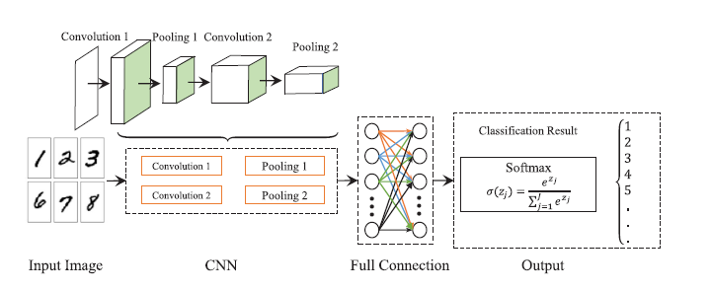

Figure 22:Normal CNN architecture

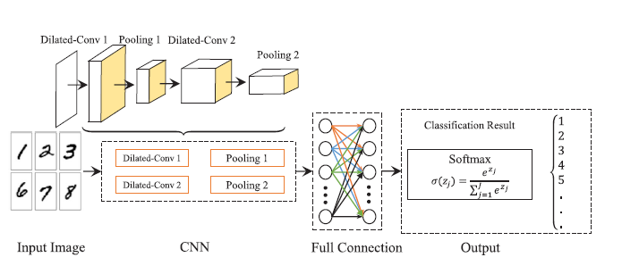

Figure 23 CNN layer with dilated core:

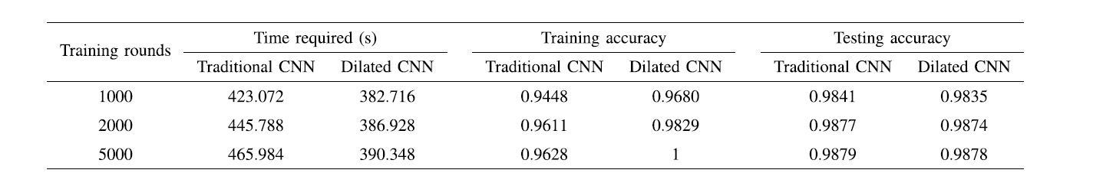

Figure 24 : Comparison between normal architecture and dilated CNN

The dilated layer will also be considered to be added into optimizing the CNN model as this will be a potentially promising technique to further reduce the training time of the model, which is the main purpose of this project.

Finally, a performance evaluation being done by (Xuefeng Jiang, 2019) for 3 different image classification techniques, which are Caps Net, CNN as well as FCN. According to this paper, the FCN neural network is a method which only contains convolutional layers in order to classify and identify each and every pixels of the images. Below illustration shows the FCN model diagram.

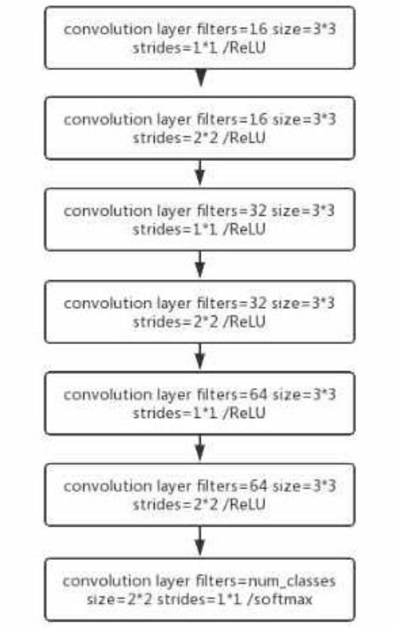

Figure 25 : FCN architecture

As shown, FCN differs from CNN because it does not contain conv layer filters, max pooling layers as well as fully connected layers. The FCN model handles the incoming data in the following way. Filters of various sizes are used in each layer to extract features and send the feature map to the next layer. After that, the last layer employs 10 filters to extract the prior feature, which is then sent to the SoftMax activation function, which generates the final probability. Although the outcome of the FCN model proves to increase the accuracy of the image classification model, the fact that the model training time is increased by a huge amount shows that the direction of research of this paper does not fulfil the requirements of this project, therefore CNN is still the ideal model to optimize and used for this project.

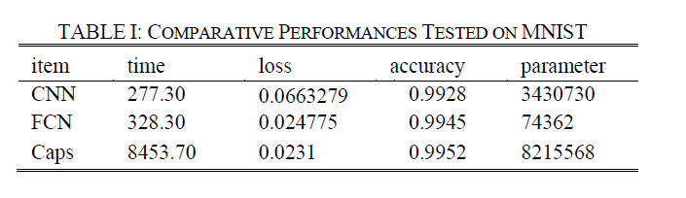

Figure 26: FCN, Caps vs CNN

## 2.4 Summary

This section of the documentation shows that there are various use cases for computer vision in retail industry, and they all share the same challenges, which is the lack of training data as well as the huge amounts of model training time needed for implementation. For image classification, deep learning is the go-to techniques for this issue due to the fact that deep learning allows computers to learn by previous examples without the need for much mathematical correlation between data columns values compared to machine learning. Deep learning techniques for image classification such as CNN have a highly customizable options to add custom layers as well as hyperparameter tuning to optimize the model, thus enabling the model to be more focused on different performance metrics.

It has been proven by the study of different research papers regarding deep learning techniques and image classification that there are many methods to achieve better performance metrics by optimizing CNN models. The fundamental understanding as well as techniques from these papers will be useful to the project success. In order to make use of these techniques, a domain and technical research is crucial to understand the inner workings of a Convolutional Neural Network.

# CHAPTER 3: TECHNICAL RESEARCH

## 3.1 Programming language chosen

For deep learning and AI, there are 2 programming languages that have been used for this task. This is due to the fact that most of the popular deep learning and AI libraries for image classification supports these 2 languages. These 2 languages are open source, which will be continuously growing as more and more developers contribute open source libraries to the code repository, improving the overall potential use cases for the languages. The pros and cons of these languages will be studied and mapped out in this section as part of the technical research, and in the end, a more ideal language will be chosen for the execution of this project.

### 3.1.1 Python

#### 3.1.1.1 Pros

The pros of python for deep learning is that this language have huge collection of in-built libraries that are catered to machine learning, data pre-processing, feature engineering tasks. Libraries such as NumPy will be especially useful for this project as it helps to convert image data into the appropriate format. Not only that, since python is a relatively easy language to pick up, developing prototypes and experimenting with different logics are easy and takes less resources compared to the rest of the languages. Not only that, there are many programming techniques that area available using python, such as object-oriented programming, which allows clean and reusable code to be written, as well as the ability to perform deployment easily as well as increase its maintainability. Not only that, python is simple and versatile, and has a moderate learning curve and is easy to learn and understand. (Robert, 2018)

#### 3.1.1.2 Cons

Python has a problem with multi-threading programming, which makes concurrency hard. Furthermore, mobile computing will be tough using python as android and IOS does not support.

### 3.1.2 R

#### 3.1.2.1 Pros

The pros of R is that it is platform independent which can run on all operating systems. Data wrangling is also possible in R, due to the fact that it has several data wrangling packages such as dplyr and readr. Finally, R supports statistical analysis, which is the main strength of R, and it is known for being a statistical programming language.

#### 3.1.2.2 Cons

There are several faults with R, mainly its data handing problem. This is due to this language making objects to be stored in physical memory. This will cause a lot more memory to be utilized compared to the rest of the programming language. Not only that, the learning curve of R is steep, as its syntax are quite complicated. Finally, in terms of speed, R is slower due to the complicated implementation in the packages. (JavaTpoint, 2019)

### 3.1.3 Why python

Considering the pros and cons, python is the more suitable programming language for the implementation of the image classification inference model. This is because python is easy to be used for experimenting. Not only that, the language is faster and consumes less memory compared to R, which therefore makes python more suitable for deep learning tasks as the data that are converted from the image array are huge. As python is better in data pre-processing and data wrangling tasks, is faster in execution compared to R, have a more robust and extensive library for deep learning compared to R, and most of all, consumes less memory. This makes python the better programming language for this task with libraries such as numpy, keras and tensorflow.

## 3.2 IDE (Interactive Development Environment) chosen

Software development requires working with multiple tools, techniques and programming languages to make the best out of the output of the software. Therefore, one of the most important aspects of software development is to choose the appropriate IDE, which is also known as Interactive Development Environment for the tasks at hand.

An IDE is a tool that allows developers and programmers to write code, compile and execute on it, hence increasing the productivity of the workflow. Not only that, syntax highlighting will aid developers in debugging codes, which in turn makes it easier for them to code functions and logics for the desired output.

Because Python is the project's preferred programming language, using an IDE or the Python Shell to develop Python code is handy for smaller projects, but not practicable while working on full-fledged machine learning or data science projects. An IDE (Integrated Programming Environment) or a special code editor would be required in this situation.

### 3.2.1 Jupyter Lab Python

Jupyter lab/notebook is basically a web application that is open source, which allows individuals to create and share documents that either contains markdown format, python scripts as well as visualization output. Jupyter lab comes with a data science toolkit, called anaconda which therefore makes it come with several important data science related libraries such as pandas, numpy, tensorflow, matplotlib and so on. Not only that, the individual working on the notebook is able to export the work into a .py file, hence aiding in the development process, making this an ideal IDE for data science related projects. (Jupyter, 2021)

#### 3.2.1.1 Pros

* Allows for the creation of blogs and notebook presentations.
* Making debugging and experimenting easy due to the creation of individual cells to check output
* Fine-tune samples until they're ready to use.

#### 3.2.1.2 Cons

* Hard to install

## 3.2.2 Vs-Code

Another IDE is used for deployment environment due to the fact that this IDE has features that are valuable in running a web application framework, such as flask, as well as web development language such as HTML/CSS and JS. Vs-Code is also part of the same data science toolkit that was used to develop this project, which is anaconda navigator, therefore it is also easy to set up a vscode environment as my model building and deployment shares almost the same dependencies.

#### 3.2.2.1 Pros

* Compatible with all platforms and production environments, as well as free and easy to install
* Strong language support, especially python, HTML/CSS and JavaScript.
* Huge extension list to make programming tasks easier.

#### 3.2.2.2 Cons

* Extensions and supports are lacking for unpopular languages (Allred, 2021).

## 3.3 libraries chosen

The implementation for deep learning algorithms requires a lot of research and documentation study behind it, which therefore is a tedious task to do so. Not only that, since different approaches are needed to be coded out using different libraries and techniques.

Python has an extensive number of libraries for the purpose of data pre-processing, deep learning model building as well as adding custom layers to the neural network. All these can be made easy by implementing the right libraries, thus making use of the functions to perform deep learning and data wrangling tasks. These libraries include:

* Numpy and OS for image data pre-processing
* Keras, tensorflow, pytorch and fast AI for building and optimizing CNN as well as image augmentation
* Matplotlib and Seaborn for performance metric data visualization

### 3.3.1 Data Processing and Modelling

#### 3.3.1.1 Numpy

This is a fundamental library that is useful to handle complicated and high dimensional array for scientific computing. This is useful for the data pre-processing phase due to the fact that image data to be inputted into the deep learning CNN model requires it to be in array format, thus numpy is needed to convert all the images into array format.

#### 3.3.1.2 OS

Python OS library is needed also to manipulate the folder structure of the image dataset. The os library is useful as it allows python to deal with data within file paths, and thus very useful to perform image data restructuring and class classification, given that the folder name is the class name.

#### 3.3.1.3 Keras and tensorflow

Keras and tensorflow are libraries designed to follow programming best practices in order for the users to implement deep learning algorithms and customized functions with ease. This library minimizes the number of user actions required for most use cases and is a common library to perform deep learning tasks. Keras library will be used to implement image augmentation and CNN model building and optimizing.

#### 3.3.1.4 PyTorch

PyTorch is an open source library for machine and deep learning framework that makes researching model building as well as product development accelerated. This library will be one of the alternative approaches to implement the CNN model for image classification.

#### 3.3.1.5 Fast AI

FastAI is a deep learning library that gives practitioners high-level components that can offer state-of-the-art results in conventional deep learning domains quickly and easily, as well as academics with low-level components that can be combined and combined to create novel techniques. It strives to achieve both goals without sacrificing usability, flexibility, or performance. This library will also be one of the alternative approaches to implement the CNN model.

### 3.3.2 Data Visualization

#### 3.3.2.1 Seaborn

Seaborn is a Python machine learning approach for displaying mathematical models—heatmaps and other types of visualisations that summarise data and show general distributions. This library is also having relation to Matplotlib, which also has data visualization capabilities as well. This therefore will be used to visualize the performance metrics to make comparisons towards the different approaches to implement computer vision algorithms.

### 3.3.3 Deployment

#### 3.3.3.1 Flask

Flask is known for being an API for python that supports the building of web-application. Since the framework is in python, the necessary python scripts, syntax, functionalities and libraries can be integrated with the web application (GeeksforGeeks, 2020). Not only that, in order for a web application to run, python allows the usage of HTML/CSS as well as JavaScript as a template for the web application to run. This framework is ideal for the deployment of the optimized models as this framework allows the models to be loaded into a python variable, and the predictions can be made accordingly. As for the image input for the predictions to happen, Ajax will be used to obtain the uploaded image data.

#### 3.3.3.2 Ajax

Ajax, which is also known as Asynchronous JavaScript And XML is essentially a technology which allows request of data from a web server. I will be using this technology to capture the image data that is uploaded to the web server to run it through the deployed and loaded deep learning model to perform predictions.

## 3.4 Operating System Chosen

Operating system chosen for the implementation of this project will be windows 10.

### 3.4.1 Hardware requirements

The hardware requirements for deep learning and model training will be stated below:

* GPU – Nvidia GPU that is CuDNN and CUDA supported, and with 4gb VRAM, for instance: GTX 1050 @4GB VRAM
* Processor – Intel® Core™ i7-7700HQ Processor 6M Cache, up to 3.80 GHz
* RAM – 8.00 GB

### 3.4.2 Software requirements

* + - * Operating system – Windows 10
      * Browser (Google Chrome)

## 3.5 Summary

Python is the ideal language for this task. Reason being that this language has a lightweight approach towards experimenting approaches and benchmarking deep learning, image classification inference models. Not only that, there are several libraries that will smoothen the process of the execution of this project to implement all the techniques documented, such as image augmentation as well as customized layer to optimize CNN models,

Jupyter Lab/notebook will also be very useful as an IDE for this task as it provides amazing presentations, and could easily turn code outputs into markdown documents and making it useful for performance metric output visualization and storytelling.

# CHAPTER 4: Chosen Methodology (CRISP-DM)

## 4.1 Introduction

A proper methodology is required for a proper execution of a business, research or software project. This is important for having a set structure of how the execution flow of a project has to perform. By having a suitable methodology that matches the nature of the project, hence making sure that all the appropriate steps are taken and completed. A proper overview of the project flow can also be mapped out with a proper methodology chosen. In general, a data analytics project includes several disciplines and components to make it a success, which consists of:

* Business and data understanding
* Data Science and model building
* Software integration and model deployment

In this project, CRISP-DM is the chosen technique. CRISP – DM is an abbreviation for Cross Industry Standard Process Data Mining, which is mainly focuses on the implementation of data mining process model that is used by majority of the data mining experts in the industry. CRISP-DM consists of 6 key phases:

(1) Business understanding, which is to understand fundamentally, what does the business needs, and this phase will be focusing on gathering requirements,

(2) Data understanding, which focuses on the dataset itself, how it will bring value to the requirements to the business,

(3) Data preparation, which focuses on prepping the data, pre-processing it into usable input format for Machine Learning as well as Deep learning models.

(4) Modelling, which focuses on the appropriate deep learning or machine learning models to utilize for a better outcome

(5) Model evaluation, which focuses on narrowing down to the best suited model for the business needs

(6) Model deployment, which focuses on the presentation of the output, and how to present it to stakeholders (Management, 2019)

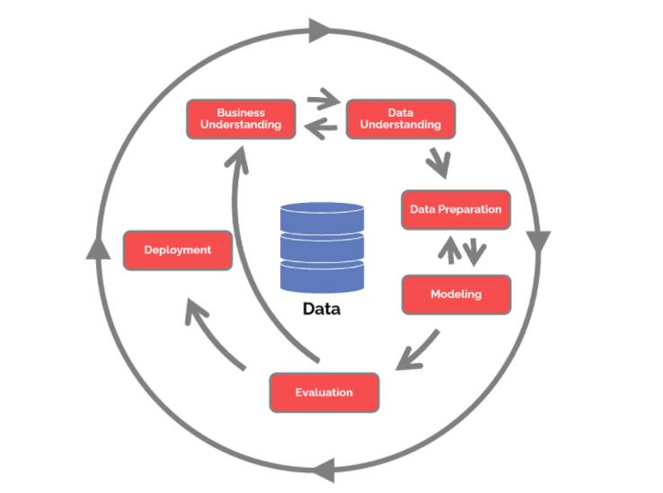

Figure 27: Crisp-DM

## 4.2 Methods (CRISP-DM)

The specific implementation steps for the deep learning image classification inference model are as mentioned below:

### 4.2.1 Phase 1: Business Understanding

In this phase, the industry requirements for building the inference model is determined. Not only that, the goals and objectives of this project with respect to the industry implementation is obtained. Furthermore, establishing the specific details of the project output is also obtained, which includes the proper performance metrics to be evaluated in the inference model. This is needed to identify the more accurate inference models approach to be utilized onto several computer vision use cases. It is also important to identify the potential roadblocks and issues that might be faced when implementing the inference models into actual computer vision use cases in the retail industry, for instance, the number of unique items and potential item classes needed to gather the dummy data for inference testing and model evaluation.

### 4.2.2 Phase 2: Data Understanding

In the second phase of the Cross-Industry Standard Process for Data Mining method implementation, data collection, gathering and understanding are needed to understand how the data can be used to be inputted into the deep learning model. Specific requirements such as the number of image classes of the data, how many images are needed to ensure the highest base quality and accuracy of the inference models and so on so forth. Once the data has been collected, concerns such as the data requirements as well as the data availability will be taken into consideration.

* Online data requirements: The appropriate image data which classes and image types are related to the predicted grocery images, which is the data mining goals achieved.
* Verify data availability: Confirmation that the data can be used as well as the data can be obtained and replaced.

The data collection will be basically a process of obtaining the appropriate image data from Kaggle. The data collected will first be structured according to its fundamental classes for the class classification effort. Each folder containing these images will be named after the class name. After that, the images will be renamed, restructured using some python functions within jupyter lab to ensure that images within the same folder does not have any additional sub classes. This effort is to reduce the number of classes needed to be learnt by the deep learning model.

### 4.2.3 Phase 3: Data Preparations

This stage is one of the most crucial stages of CRISP-DM, as data pre-processing is usually 60% of the analytics work. Efforts to preprocess the data into appropriate input format for the deep-learning/Machine learning model in the fundamental objective of this process. In the case of image classification, techniques such as image augmentation, image data conversion is needed to convert the images into Numpy array to be inputted into the deep learning model. Not only that, an appropriate labelling function is also needed to ensure that the tagging of the images into the deep learning model are able to accurately predict future images. Usually, in this phase, it includes six tasks, which contains:

#### 4.2.3.1 Selecting Data

This section is basically choosing which portion of the data columns are needed to be used by the prediction models. However, this phase will non be needed as all the features in the NumPy array will be crucial as input into the deep learning model.

#### 4.2.3.2 Cleaning Data

This phase would be to clean the data, whereby missing values and noise in the data are handled. Hence, identification of faulty or blurred image which can potentially decrease the precision and accuracy of the prediction outcome will be removed.

#### 4.2.3.3 Constructing Data

In this section, usually additional columns containing useful features are added into the dataset to increase the prediction outcome, hence, in a image classification inference model process, this is not applicable.

#### 4.2.3.4 Integrate Data

This process involves the process of merging data from various sources into one tabular format. In relation to this project, the folder structures are already an indication that the data has been integrated manually.

#### 4.2.3.5 Transforming Data

After the data integration phase, data transformation efforts such as converting image data and augmented images to NumPy array, appending a column of labelling based on the image classes.

#### 4.2.3.6 Storing Data

Finally, in this phase, the converted image data in form on NumPy array as well as the labels of the converted images will be stored into a format that allows input into deep learning models.

### 4.2.4 Phase 4: Data Modelling

In this phase, the deep learning models and approaches are made use of in order to process and learn from the existing image data. This section covers research regarding the potential methods to optimize the selected deep learning models to perform image classification tasks. Not only that, other potential models are also taken into consideration. There are 4 tasks that are included in this phase:

#### 4.2.4.1 Selecting modelling techniques

There are several deep learning models, techniques and approaches to handle image classification. These different models and approaches will be researched and methods to optimize them will be researched as well in order to perform adequate comparison between the performance metrics of the inference model being built

Deliverables of this sub section includes:

Deliverables for this task include one report:

* + - * + **Modelling technique:** Convolutional Neural network will be used.

#### 4.2.4.2 Designing tests

Several benchmarking tests have to be done to not only evaluate the performance of a single model and approach, but also for all the other approaches that have been implemented for the inference model. First of all, in order to evaluate the model training time, the output of the model summary has to be recorded, and any changes in the techniques before training the model, which causes changes in the model training time will be recorded and taken into consideration as well. Not only that, the performance metrics of the other approaches will also be documented and recorded in a similar manner with the purpose of creating visualizations mapping out the performance metrics of these implementation approaches.

#### 4.2.4.3 Building models

In this case, custom optimization techniques will be used to alter the deep learning CNN models according to the business use case and industry requirements. The deliverables in this section will include:

* **Parameter settings:** This includes the tweaking of the parameters in each of the custom layers in the CNN models. Parameters that can be tweaked are the activation function, the layer type and so on so forth. Not only that, the number of layers added into the neural network in general will also be considered
* **Model descriptions:** The type of deep learning model used is Convolutional Neural Network, and the predictors used are basically all the image data which are converted using NumPy array in addition to the labels.

#### 4.2.4.4 Assessing models

The performance metrics will be reviewed from a technical as well as with respect to the industry use case.

There will be 2 deliverables for this task:

**Model assessment**: Visualizations of the performance metric with relevant metrics displayed, and model analysis will be presented.

**Revised parameter settings:** This will be consisting on several potential techniques, convolutional layer settings as well as related parameter tweaking to further improve the performance of the model.

### 4.2.5 Phase 5: Testing and Evaluation

At this point, the assessment of the inference models and the different approaches taken should be tested to ensure that the performance metrics generated has less variability. The performance evaluation phase will consist of 3 tasks:

### 4.2.5.1 Evaluating results

In this subphase, the results of the models, mainly the performance metrics of these approaches will be done. Metrics such as model training time as well as the accuracy of these models implemented using different approaches will be derived, and critically analyzed with respect to the industry use case.

### 4.2.5.2 Reviewing the process

After the model outcome have been analyzed, the entire project execution workflow will be analyzed. The purpose of this process is to find any faults that may have been overlooked and if there are any additional time to complete the project, the kinks that have been found in this phase can be acted upon.

Hence, the deliverables of this task will include:

* **List of possible actions**: A description of alternative techniques and approaches that could be used to obtain better results, or improve the research outcome.
* **Decision:** Stating a final decision on each possible execution plan, in addition to the purpose of the decision.

### 4.2.6 Phase 6: Final Deliverable (Deployment)

The final step in this case will basically be the report generation in terms of visualization and tables to present the evaluation and performance metrics. These reports will consist of the metrics with respect to different approaches of the inference models. This deliverable will be presented to the individuals that are responsible for implementing computer vision and image classification into the retail and grocery industry, which will assist them in making use of the approaches that are researched in this project. Not only that, based on the research outcome, directions and research of the implementation will be made use during the implementation of the inference models for various use cases in the retail and grocery industry. The best models will be deployed into a web application alongside the Dashboard metrics visualization as the final output of this project.

### 4.3 Summary

A description as well as the details on each of the phases with respect to the project execution plan has been documented in this chapter.

First of all, the business understanding phase will allow requirement gathering as well as understanding of the aim and objective regarding the project. In this case, the requirements is fundamentally to identify the optimal approach to implement image classification model in the retail industry.

During the data understanding phase, the number of images that is required to test the model, as well as the amount of class labelling needed in relation with these images are determined.

Furthermore, basic data preprocessing will be carried out by converting the images into the appropriate format. Not only that, the labelling of these images will also be done in this section.

In the modelling phase, deep learning models will be selected to be used to build the inference image classification model. Not only that, the techniques and different approaches to optimize and build on to the selected model are discussed here.

Finally, testing process will be conducted to determine if the results and research process from different approaches are beneficial to the outcome of the industry. The business understanding in revisited to determine if the output of the project matches the requirements of the industry.

# CHAPTER 5: DATA ANALYSIS

The output of the project will be basically 2 different optimized model, whereby one model is used to predict a generalized classes, therefore more images per class as training data. These classes are, Fruit, vegetables and packages. Another model will be used to predict more number of classes, hence less image per class. The total number of classes are 36. (Apple, milk, potato, tomato and so on so forth.)

## 5.1 Data preprocessing

### 5.1.1 Image data structuring

In the beginning of the project, since all the images are named in a chaotic format, so a python function has been written to rename them in a proper manner. This is done using the os python library. This is done so that during the image loading phase, as well as the class restructuring function in the later stages of this project can be executed in a smooth manner.

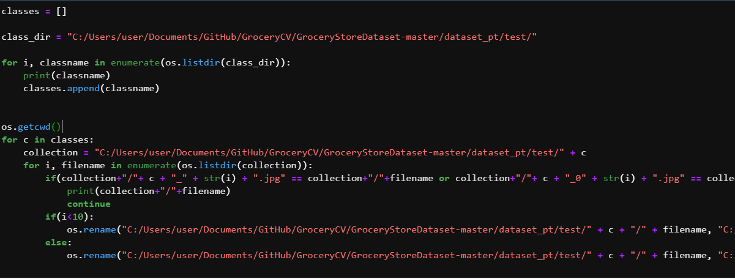

Figure 28:Image file renaming function

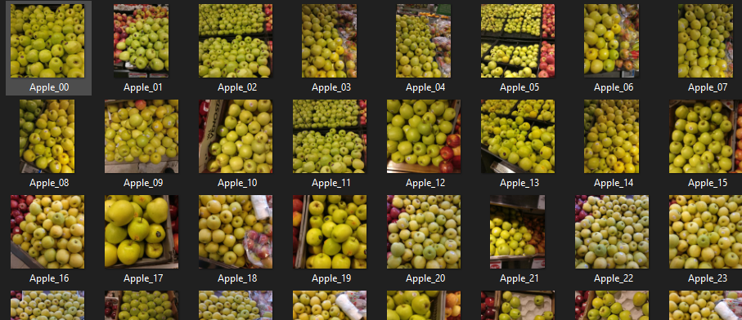

Figure 29:Renamed apple images

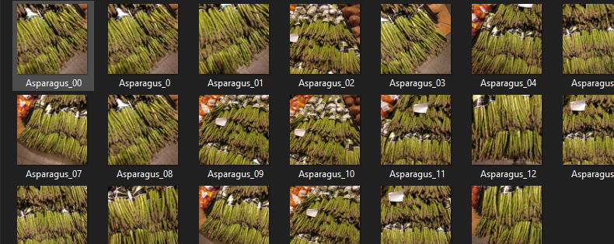

Figure 30:Renamed asparagus images

After this function has been executed, and since the project outcome is to deploy 2 different optimized models, one for less class, and one for more class, another function is written to change the class label structure of the training and the testing dataset. This is done using the python shutill and glob library.

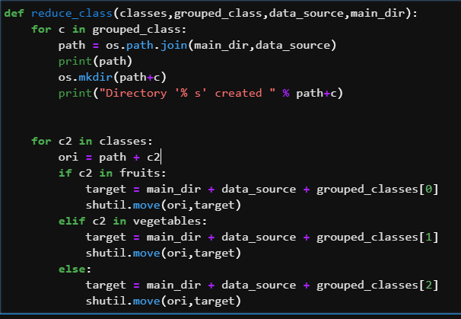

Figure 31:Function to reduce class

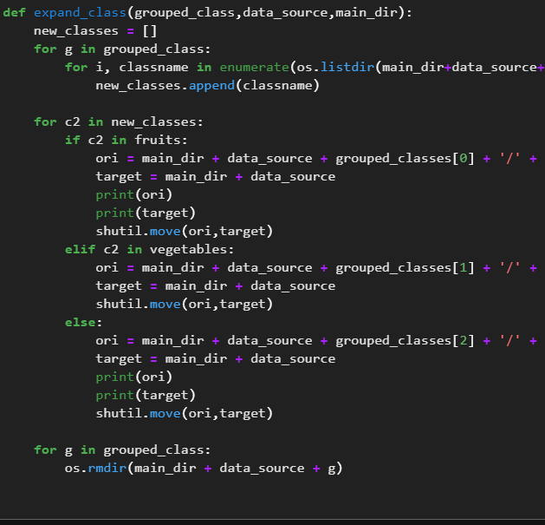

Figure 32:Function to expand classes

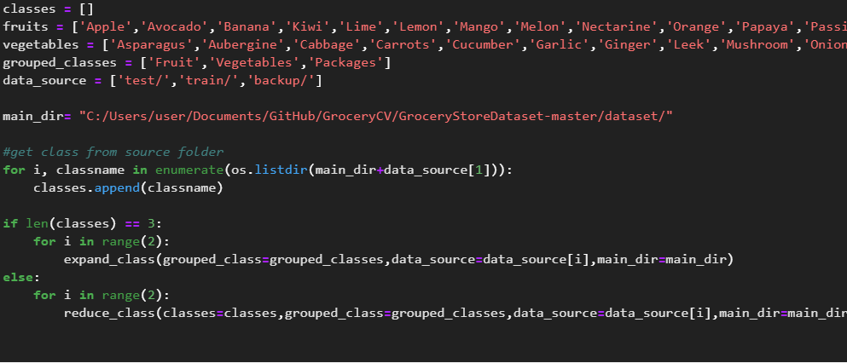

Figure 33: IF statement to determine which function to execute

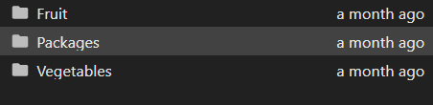

Figure 34:Output 1

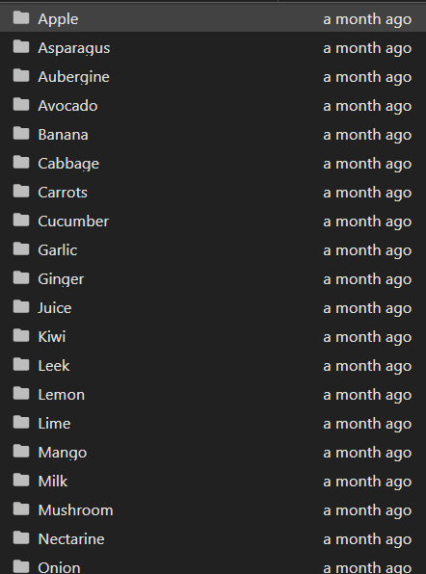

Figure 35:Output 2

### 5.1.2 Image data processing

There are different image data processing functions that are used. For instance, image data generator and tf.data is used for the tensorflow+keras combination, Image data bunch for Fast AI as well as torch vision transformer and data loader for pytorch.

#### 5.1.2.1 Tensorflow + keras

For this approach, before accessing the image dataset, a datagen object is created for the training image data as well as the validation image data. Techniques applied here are image rescaling, random rotations, width, height and sheer range shift, as well as zoom_range shift for the image augmentation. After that, the datagen object is applied on the all the images in the training set in order to perform **image augmentation.**

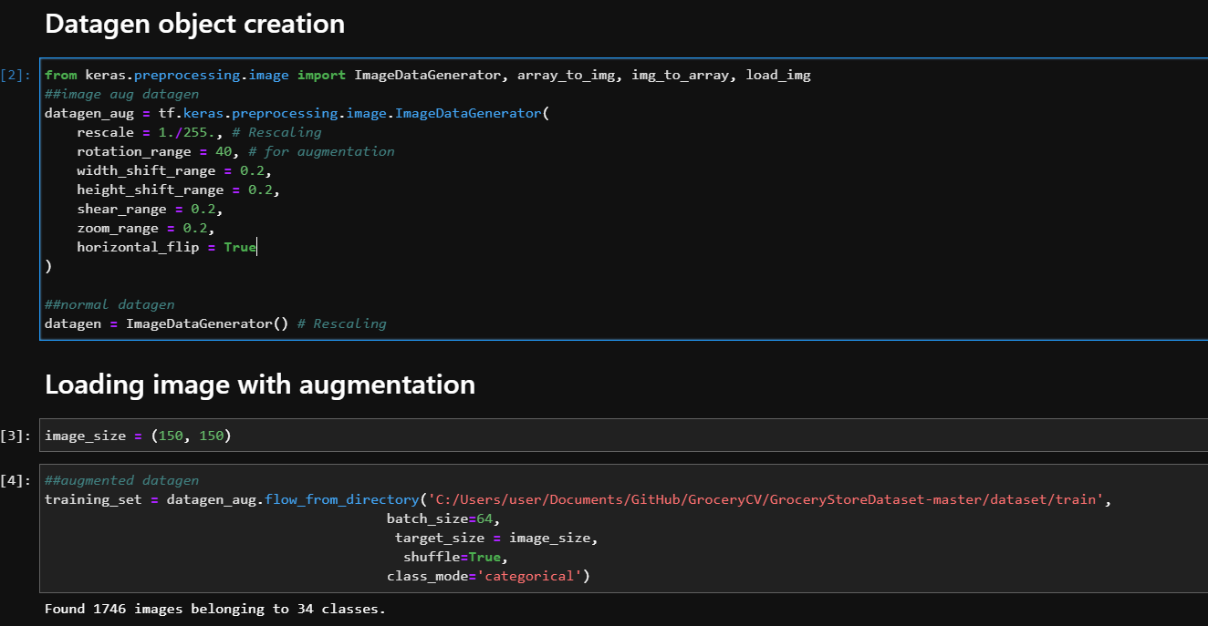

Figure 36:Image loaded using datagen object

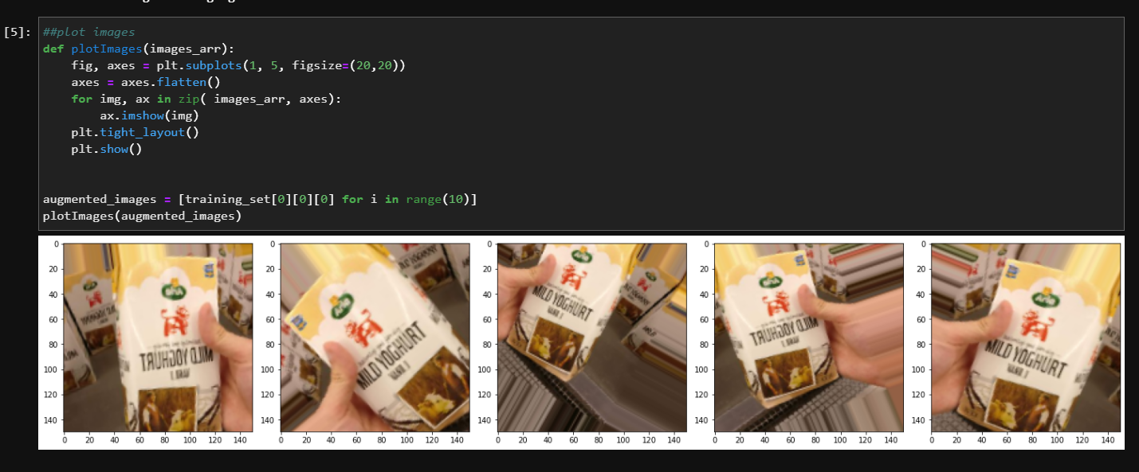

Figure 37:Augmented image visualized

Not only that, another data loading method has been experimented in tensorflow as well, which is the technique called **tf.data**. This technique basically creates a pipeline from the image dataset to the model input layers, in an attempt to reduce memory usage. This technique is experimented to see if this will have an effect on the model training time. As shown in the illustration below, in order to apply this data pipeline on top of the image data generator, the directory of the image data has to be stored in a variable using the list files function. After that, a lambda function has to be used to apply this technique in accordance with a output type and shape parameters, which will be resized back to (150,150).

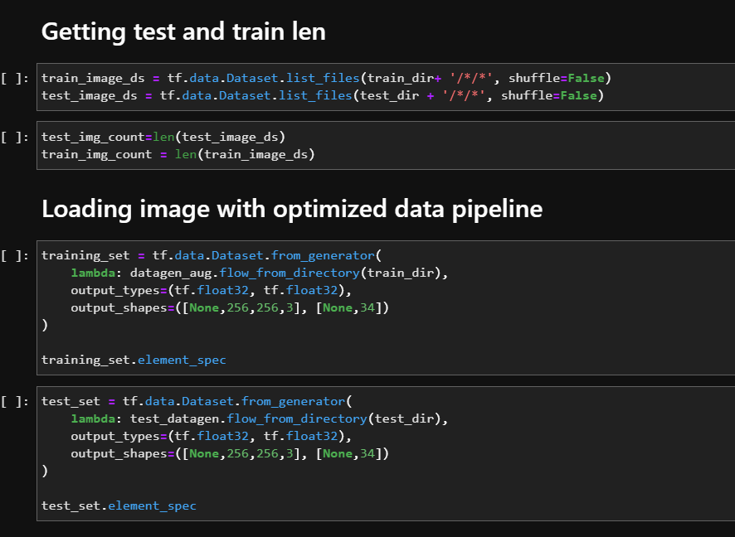

Figure 38:Tf.data implementation

Finally, the class indices (labels of the images) are extracted from the image data, and mapped using a dictionary. This is for the usage of the model building process. Note that, the labels are dependent on the structure of the training data. Hence it corresponds to the number of training and validation classes.

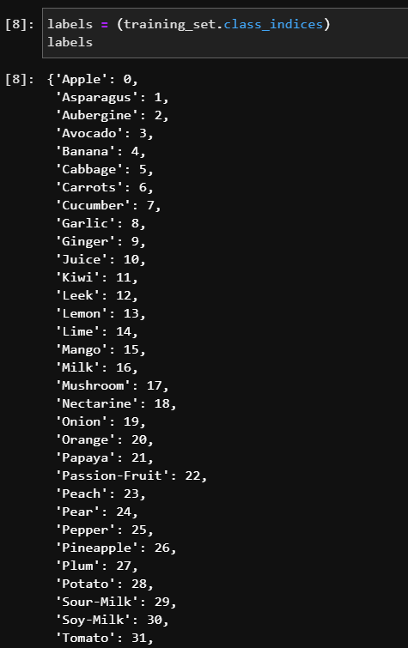

Figure 39:Parsed labels

#### 5.1.2.2 pyTorch

In pytorch, the image transformer object is used to perform **image augmentation**, as well as **image normalization**. In this case, the image normalization is done by converting the pixels in a range of -1 to 1, using the formula **(x-mean)/std.**

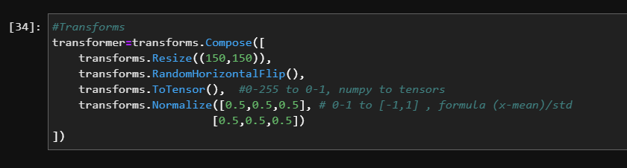

Figure 40:Transformer object pyTorch

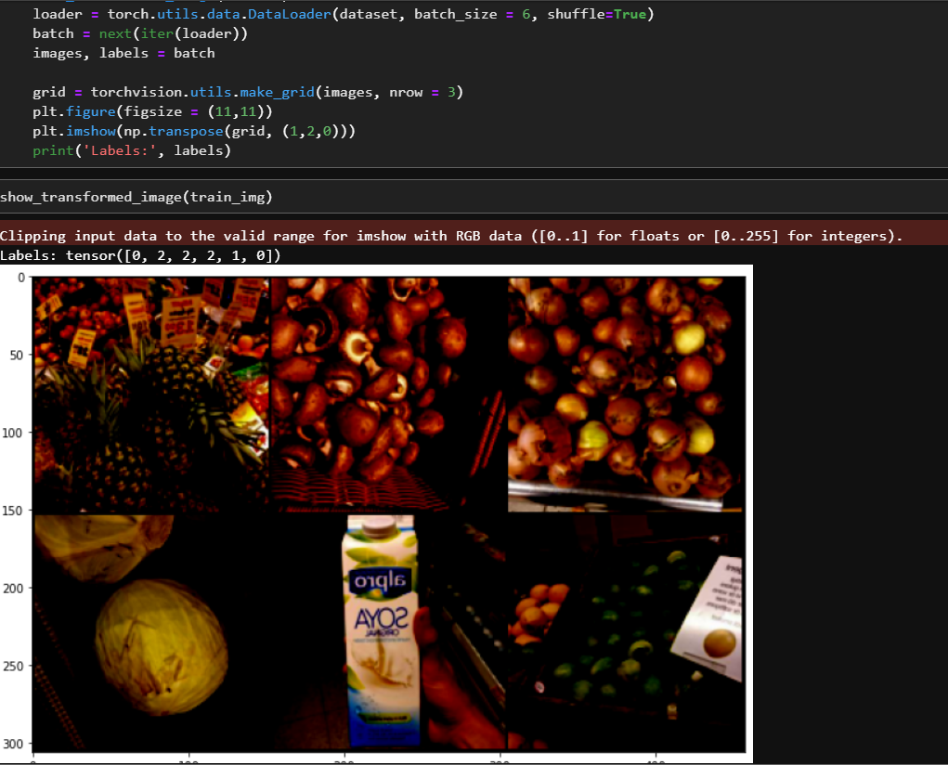

Figure :Transformed images

Finally, 2 minor tweaks have been done in loading the data into the model. Similarly, the dataloader pytorch function has been used. However, approach 1 is to load the directory and apply the transformer **before** loading the data into the train and test loader variable for model input. Approach 2 is to apply the image transformer **while** loading the data into these variables. These 2 approaches are hypothesized to have an effect on the model training time due to the memory allocation being different in both methods.

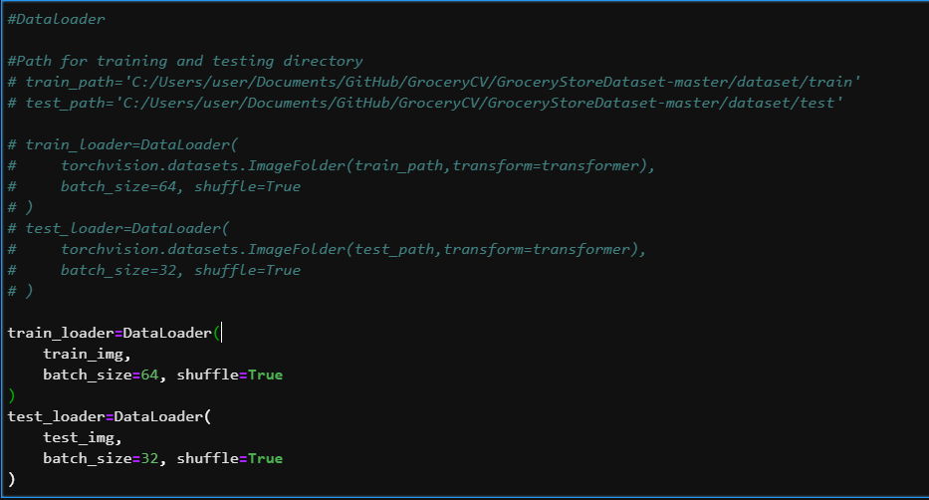

Figure 42:Both approached of data loading function (commented code is version 1)

#### 5.1.2.2 FastAI

Since fastAI is a high-level API to perform simple deep learning and image classification tasks, their image data bunch function allows image augmentation as well as image normalization with only a few lines of code. Below illustration shows the output of the normalized data.

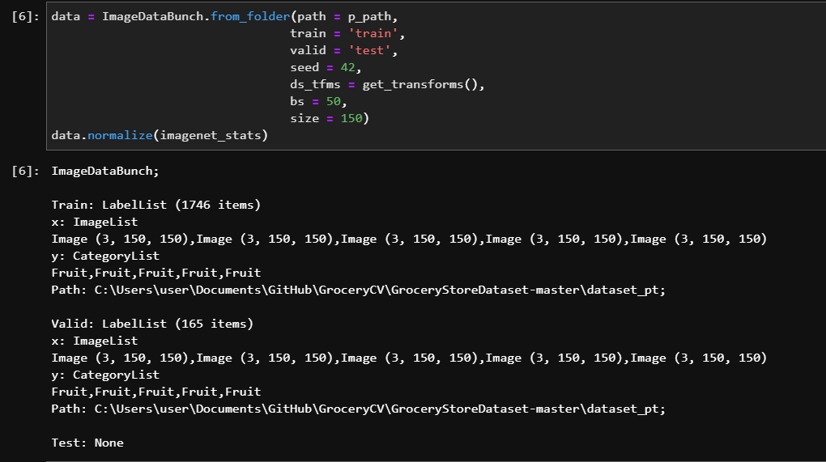

Figure 43:Data normalization and augmentation

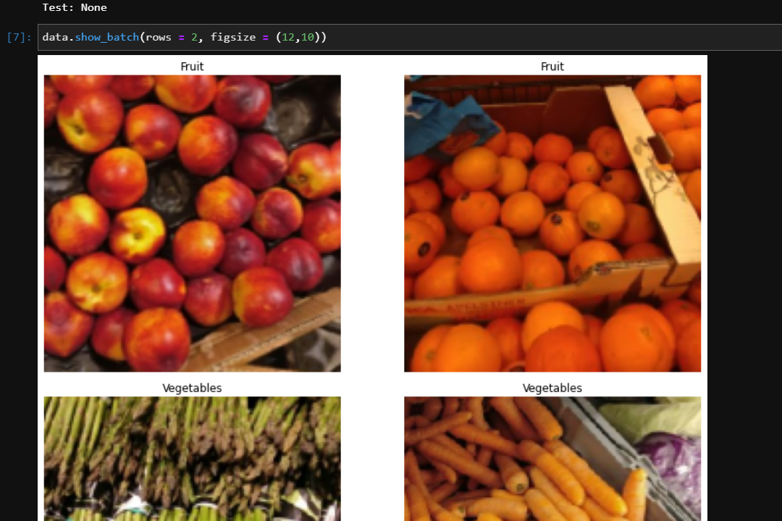

Figure 44:Output image

## 5.2 Model building

As mentioned in the above section of the documentation, there will be 2 optimized model that will be chosen to be deployed. One with generalized less classes and one with more classes. There are several experimentations in hyperparameters, as well as techniques applied in the model building process.

### 5.2.1 More Class

#### 5.2.1.1 Tf+Keras

First of all, the base architecture of a CNN model is built, with random parameters as hidden units. Not only that, a batch normalization object has been created to add to the model architecture.

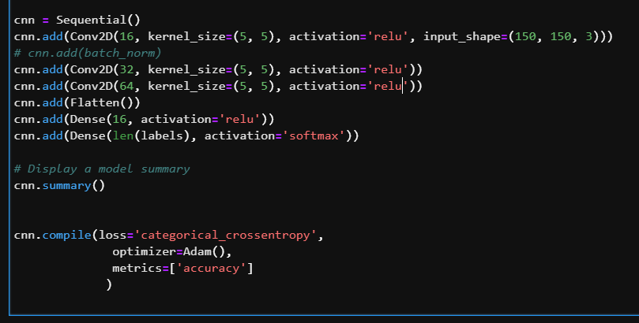

Figure : Keras base model architecture

After the accuracy and training time for this is obtained, keras tuner library is used to perform hyperparameter tuning for the model architecture to further optimize the performance metrics of this model architecture. As shown from the illustration below, the relu activation function is used here as well as the first input layer is given as a constant. The hidden units and the kernel size of the rest of the layers will be tuned using the filters, hp.Int and the hp.choice function within the tuner. Finally, the Adam optimizer is used as a constant, however the weight decay and learning rate is further tuned.

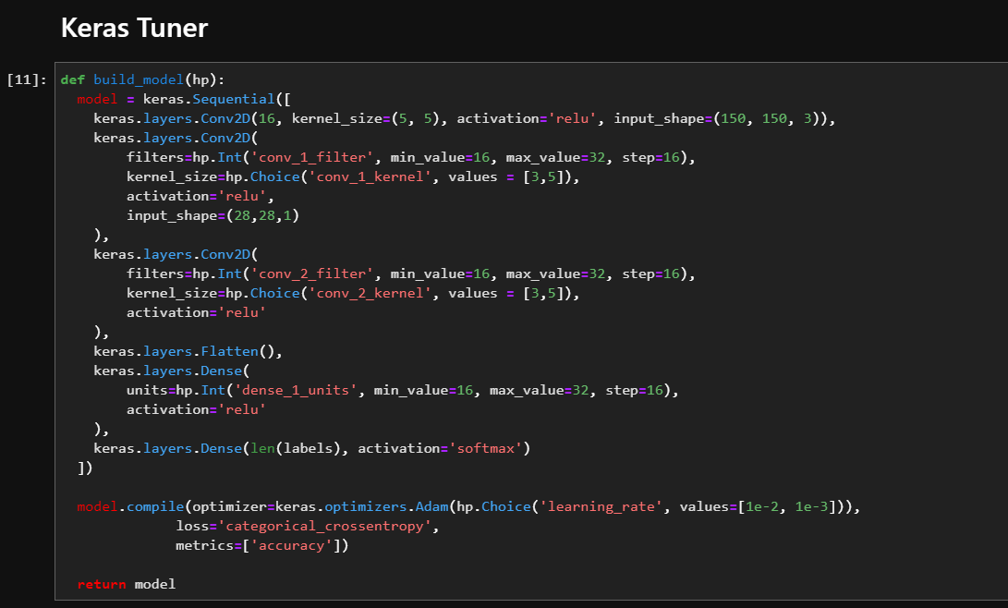

Figure 46:Hyperparameter tuning using keras tuner

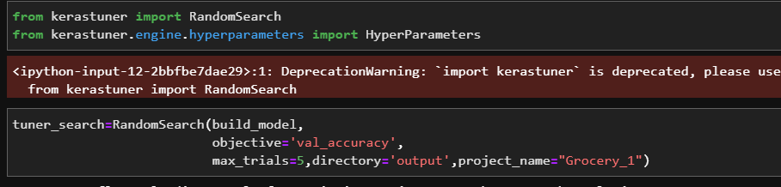

Figure 47:Random search technique is used for the hyperparameter tuning process

After that, transfer learning using TensorFlow is also applied on this dataset. According to the illustration below, a pre-trained model and weights are loaded, and the top and bottom layers are removed. After this, the input layers are added according to the input data, and the output layers are added according to the desired prediction outcome.

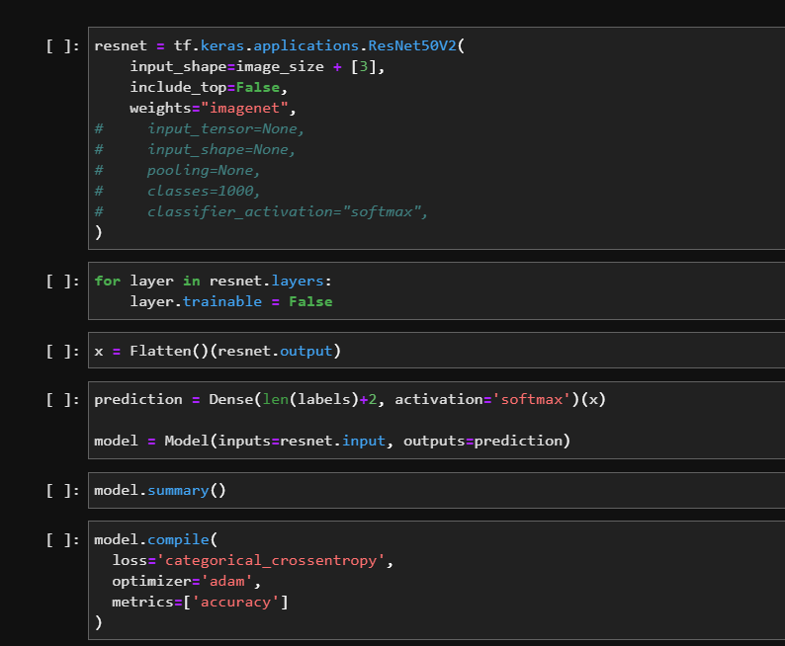

Figure 48: Transfer learning

#### 5.2.1.2 pyTorch

As pyTorch allows more customization to be made in the model building process, there are a lot more parameters that was tweaked to obtained the desired model output based on the image shape input and output for every hidden layer. The calculation has been written in the model architecture itself in the below illustration. Not only that, the activation function tanh here has also been experimented. Finally, a forward function has been added in the model architecture as well, in an attempt to increase the performance metrics of this model architecture.

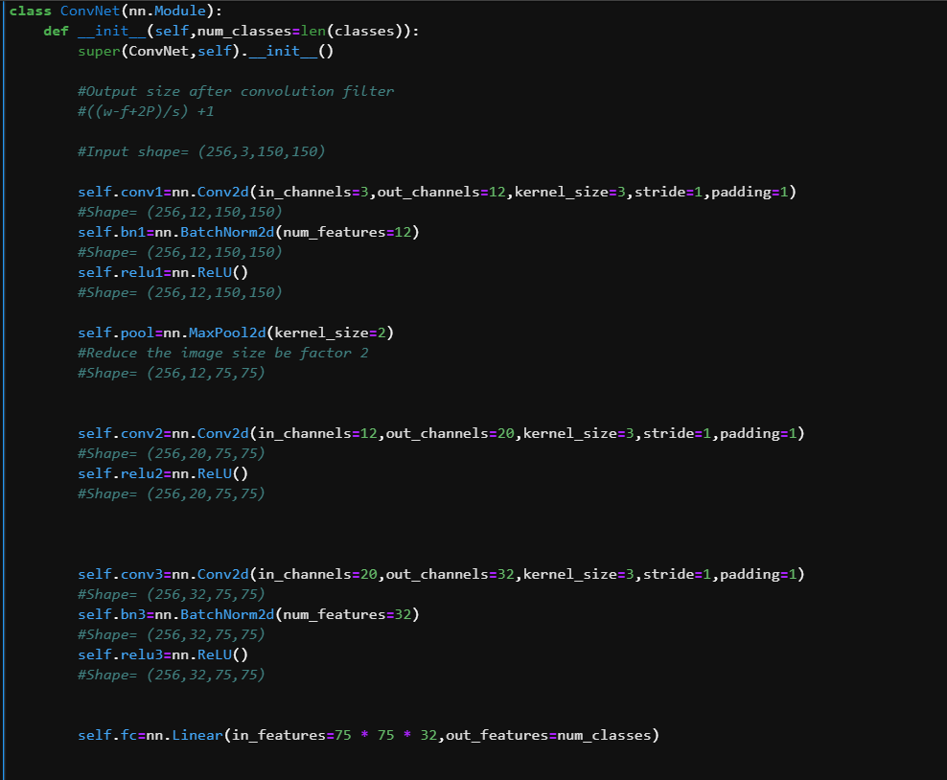

Figure 49:pyTorch Model architecture

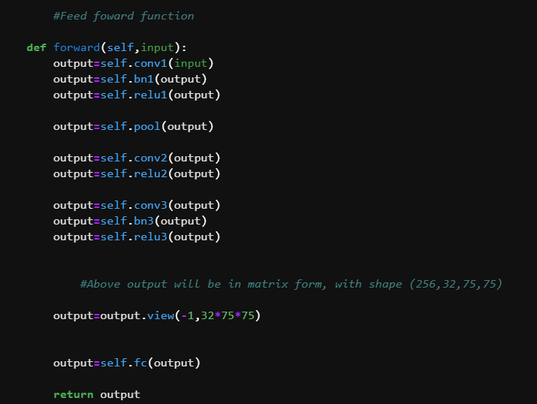

Figure 50:Forward Function

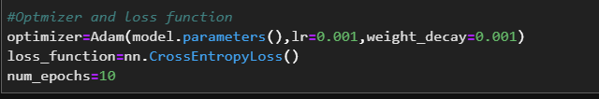

Figure 51:pyTorch optimizer params

Similarly, to the tf+keras combination, transfer learning is also being experimented in the pyTorch API for deep learning and image classification. Same thing is happening here, the input and output layers are added in accordance to the corresponding use case.

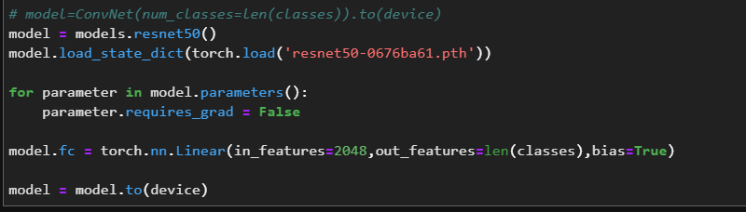

Figure 52:Transfer learning model building pytorch

As for the hyperparameter tuning process of pyTorch, a function is written as well to perform evaluation for different learning rate and weight decay for the self-made model implementation that was generated.

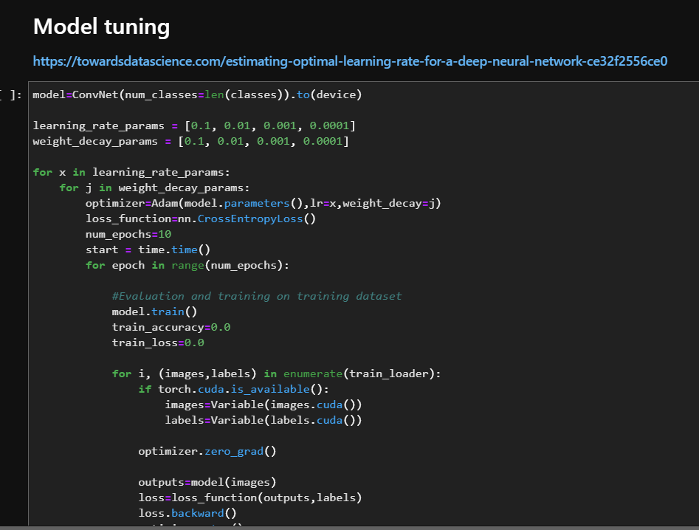

Figure 53:pyTorch hyperparameter tuning

In addition to that, a transfer learning optimization has also been done. Note that the transfer learning technique that was applied above, was only using the pretrained model, altering the input and output layer based on the problem statement. Additional accuracy can be obtained if a training process is happened on top of the pre-trained model. Not only that, some functions can be written to optimized that particular training process as well. In order for all this to be possible, several functions are needed. Below illustration shows a train model function, which takes in the train dataset, test dataset, loss function and optimizer as input params. This function is also used to train all the pytorch model implementation. Basically, how this function works is that it will take the train_loader variable, that was loaded with the train data, as well as the test loader variable, which contains the test data. These loaders contain the labels and the images; therefore, these data are enumerated using for loops, and the data are leaned by the model. Note that, while training, there are some variables that are computed while training, such as the train_accuracy, train_lost, as well as the _predictions. The train acc as well as the train lost variables are calculated, based on the number of accurate prediction count against the number of inaccurate counts.

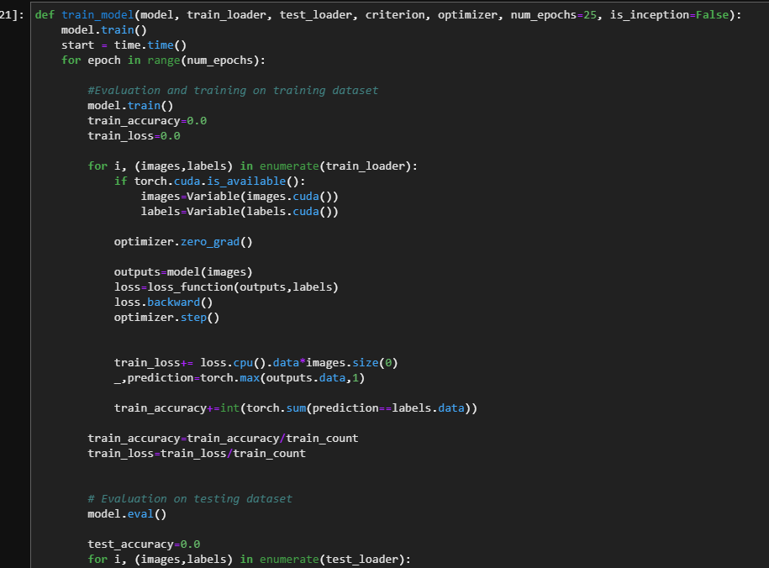

Figure 54: Train Model function

After that, the model initialization function is written to take in the model name, and initialize that model with appropriate parameter and in feature requirements for the corresponding models. As there are multiple pre-trained models out there as well, hence another function is also written to perform evaluation onto all these other optimized pre-trained models.

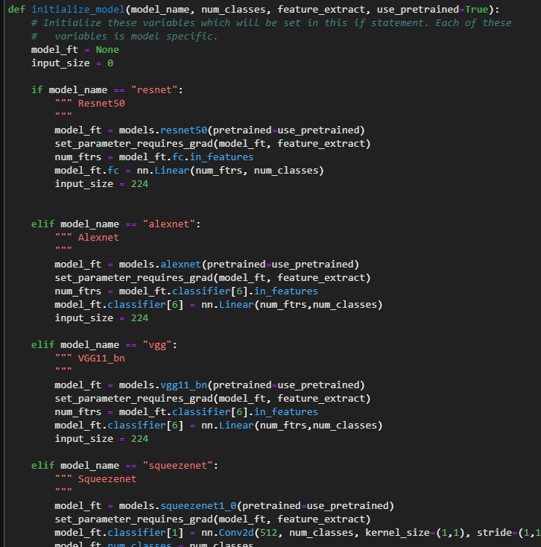

Figure 55: Initialize models

Furthermore, a series of code is written to determine the parameters to update and train for each model. The optimizer function will be based on the output of the parameters to update variable.

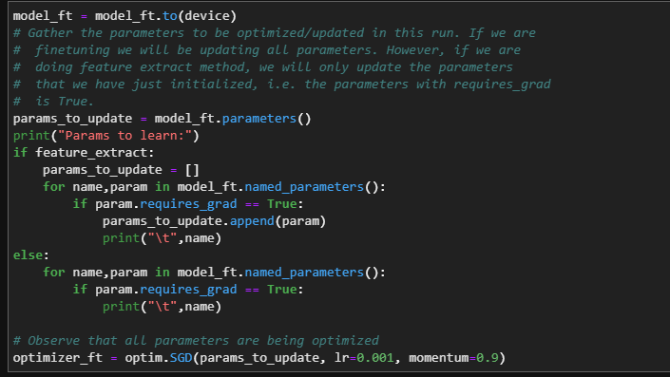

Figure 56:Optimized training parameters

Finally, to bring all these together, the transfer learning model names are placed in an array. After that, the array names will be iterated using the for loop, “for model_name in model_names”, and the above functions will be called in a succession in a loop to perform evaluation on all the optimized transfer learning model. The evaluation metrics will be tracked, and another separate BI dashboard will be generated for this, and embedded into the web app as well.

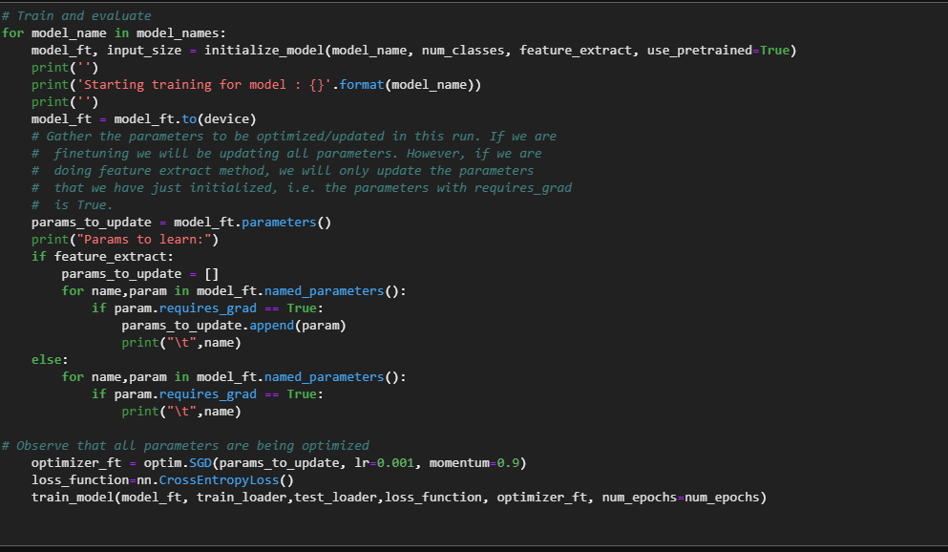

Figure 57: Transfer learning evaluation

#### 5.2.1.3 FastAI

For fastAI, since it’s a high level API built on pyTorch, the only available technique is transfer learning. Hence as shown in the illustration below, transfer learning is done for the model building process using this API.

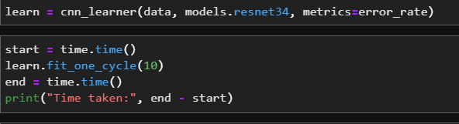

Figure 58:FastAI transfer learning

### 5.2.2 Less Class

#### 5.2.2.1 Tf+Keras

Approaches are the same as the “More class” section of the documentation

#### 5.2.2.2 pyTorch

Approaches are the same as the “More class” section of the documentation. However, in this case, optimized transfer learning is not needed because with a low training time, the self-build model is able to already obtain a good accuracy.

#### 5.2.2.3 FastAI

Approaches are the same as the “More class” section of the documentation

## 5.3 Evaluation

In this phase, the results of the performance metrics, and the final deployed optimized CNN model is chosen based on the evaluation results. The detailed results will be further explained and analyzed in Chapter 6. The output of this phase is the 2 optimized models, which will be deployed as a prototype alongside a power BI metrics dashboard.

## 5.4 Prototype deployment

For this implementation, both optimized models are deployed side by side in one web application using the flask python framework. The frontend of the webpage is designed using HTML/CSS stack. Not only that, JavaScript as well as AJAX are both used to perform the input and output of image data for the models to perform prediction. The predicted images will be stored in an uploads folder whereby the user can keep track of predicted images. Not only that, the python image library, Pillow has also been used in the deployed web application to convert the image data into a desired format for the model to perform prediction. How this web application works will be discussion in the technical explanation part of the documentation.

## 5.5 Technical explanation

In order for the prediction to happen, both deep learning model will be loaded and the prediction device is set to cpu. This is so that a device without a GPU is able to perform predictions using the deployed optimized model.

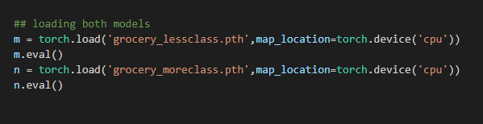

Figure 59: Model loading

After the models are loaded, the prediction function is written and this will be called in the GET request async function in order to pass the predicted image to be returned in that function. Since we have 2 models, there will be model_predict and model_predict2, as well as 2 async functions for the prediction output, route(‘/predict’) and route (‘/predict2’).

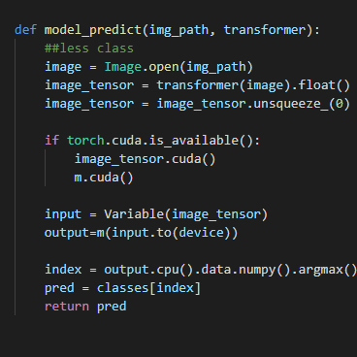

Figure 60: Model predict function

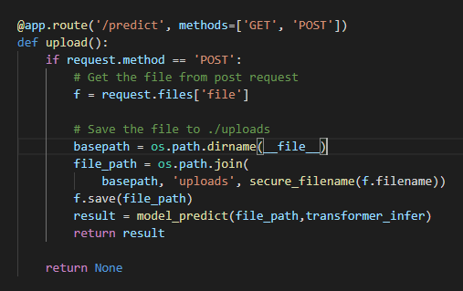

Figure 61:Async function to output prediction

Note that, the image data obtained from the AJAX function, will be gone through a transformer to resize, so that it is able to fit into the input layer of the deployed model.

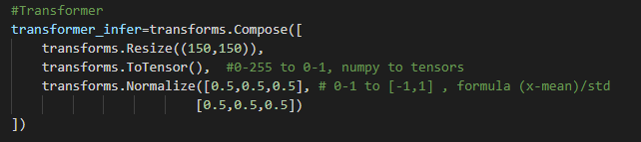

Figure 62:Transformer object

The image data will be obtained using an AJAX function. Initially, the upload preview will be showing the image that was uploaded to the web application.

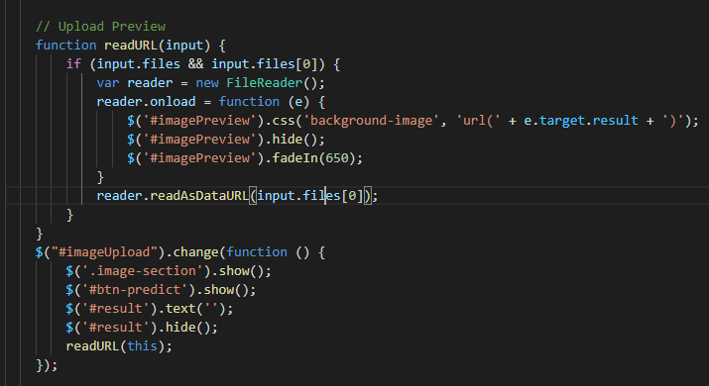

Figure 63: Upload preview after uploaded image has been loaded

Finally, the predict section of the AJAX function, will pass the uploaded image to the app.route function.

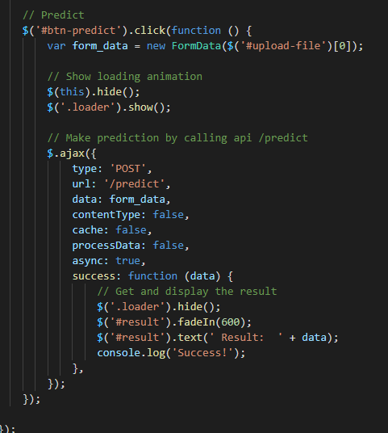

Figure 64: Passing uploaded image data to the approute function

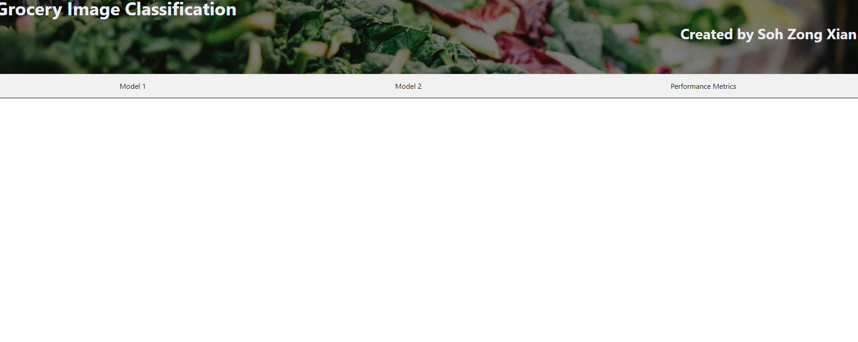

Figure 65: Front UI of the web app

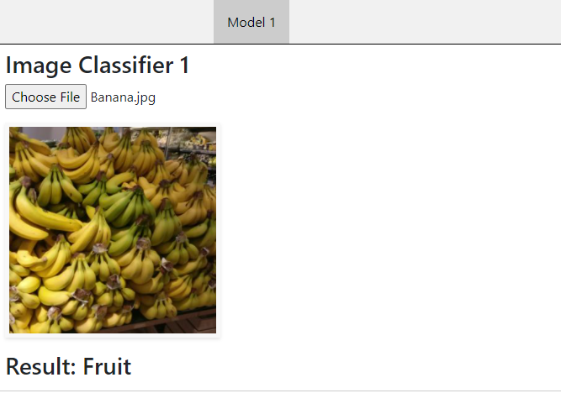

Figure 66: Model 1 output will be to predict generalized classes

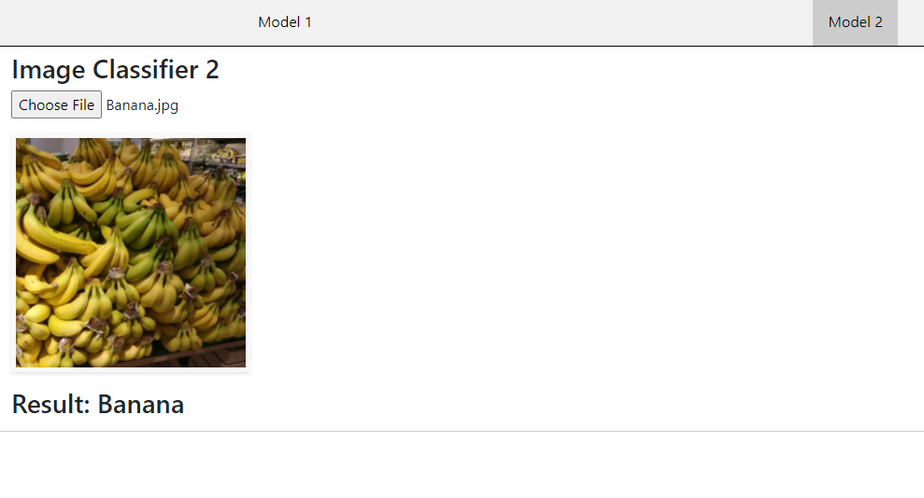

Figure 67: Model 2 output will be to predict specific classes

The third tab will contain a powerBI dashboard containing the performance metrics that is correspond to the techniques and approaches that have been applied. The dashboards are created to evaluate accuracy as well as model training time.

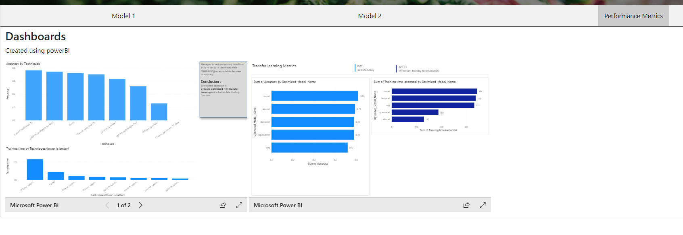

Figure 68: power BI Dashboard

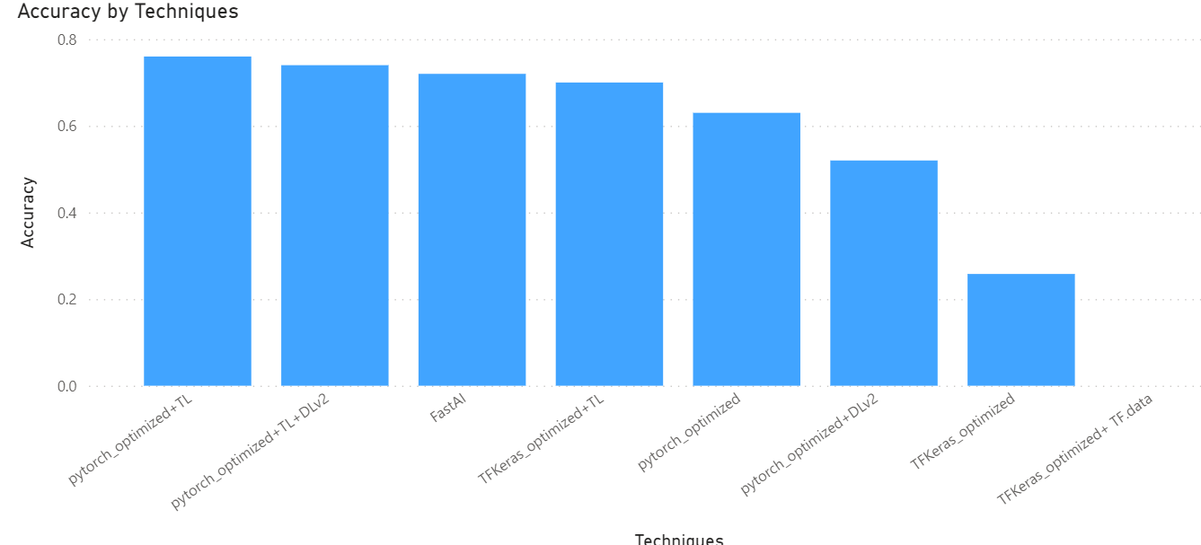

Figure 69: Accuracy by Techniques

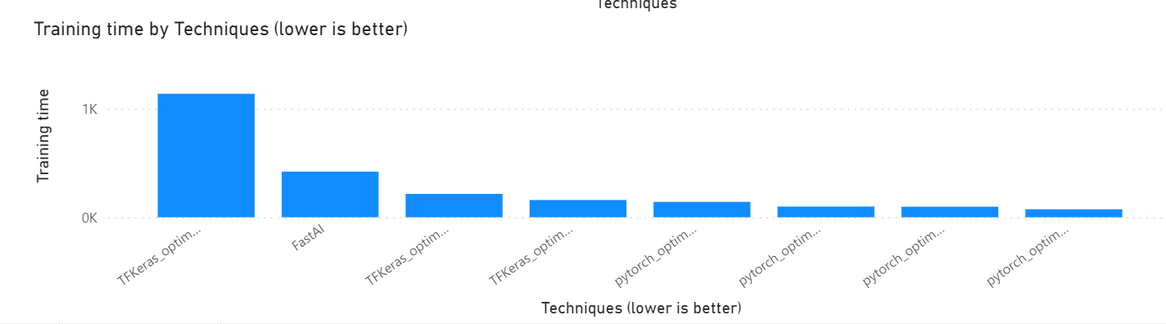

Figure 70:Training time by techniques

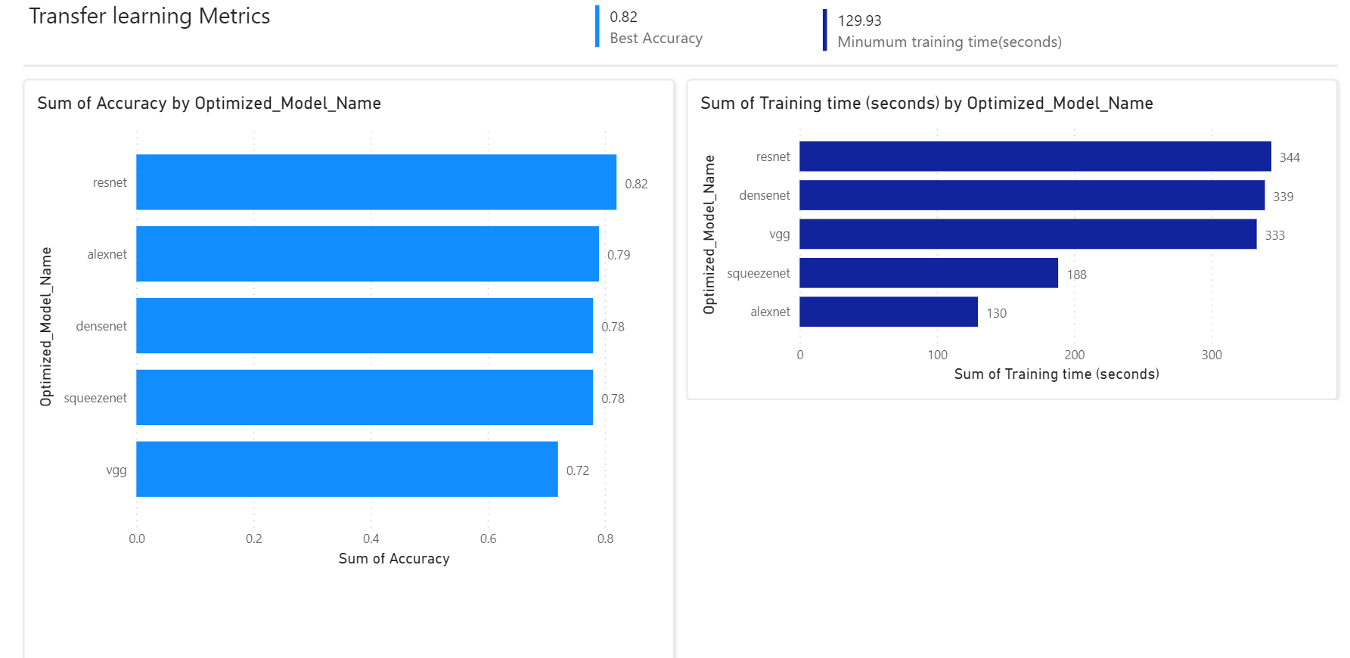

Figure 71: Dashboard for transfer learning evaluation

# CHAPTER 6: RESULTS AND DISCUSSION

Note that, in all the techniques and approaches, image augmentation is applied.

## 6.1 Tensorflow + keras (More class)

First of all, a simple CNN with 3 Convolutional layers and a dense layer is made the model architecture, and the image dataset is trained on it using keras.

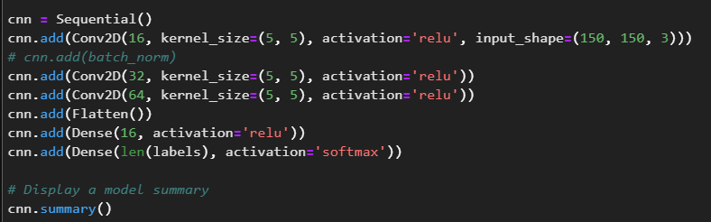

Figure 72: Base CNN model architecture (Keras)

Batch normalization is also being experimented in the model architecture to evaluate the results of this model architecture. The results weren’t satisfying, as it yields a <1% accuracy.

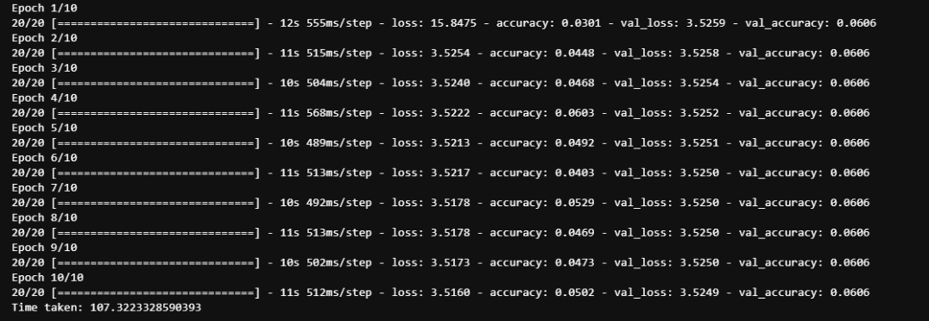

Figure 73: Result of tensorflow + keras (base)

After that, keras tuner is used to tune the relevant parameters and hyperparameters of the model architecture. Even with the tuned hidden layers and the parameters, the results Is still 24%, which is not good enough for an industry use case.

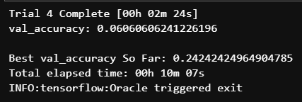

Figure 74:Keras tuner outcome

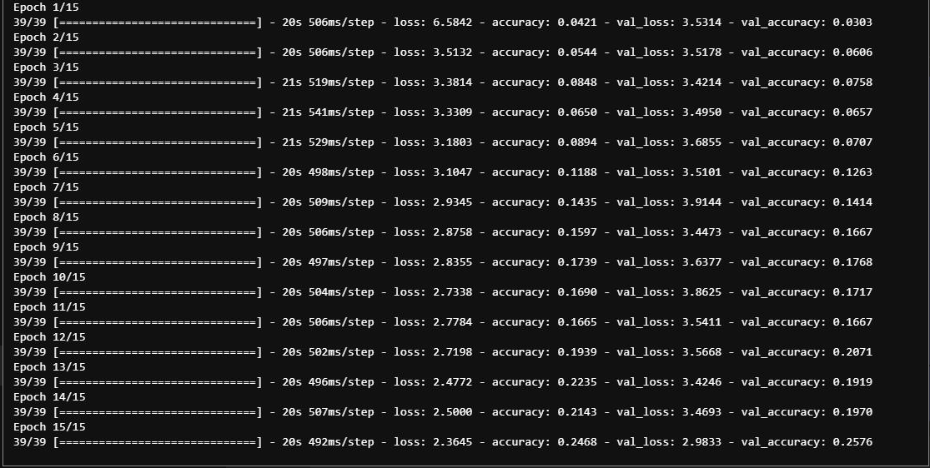

Figure 75:Tensorflow + keras optimized

In tensorflow, there are some transfer learning models that are available for this use case. Therefore, transfer learning is used, and the yielded results is shown below. The results now become more suitable for this use case, as a 70% accuracy as been achieved.

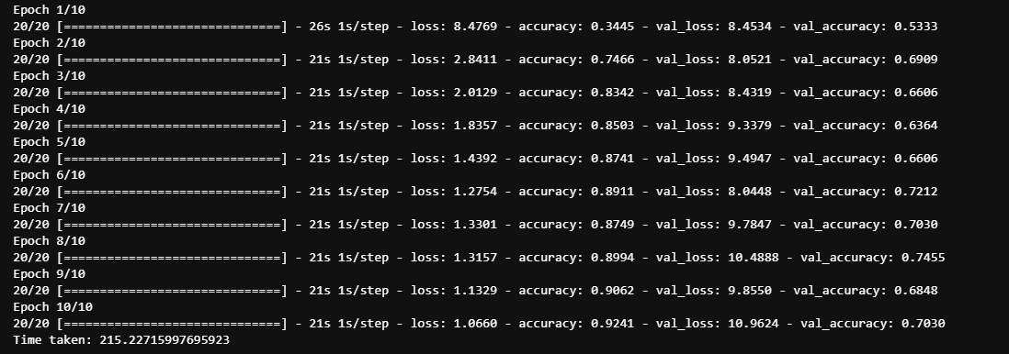

Figure 76: Transfer learning with keras

In an attempt to improve the model training time, a different data loading technique has been experimented. This is called tf.data, and an optimized pipeline between the data folder and the model architecture. In theory, this technique is used to handle huge datasets, and the resources is optimized. However, this is not suitable for our use case, as the model training time far exceeds the rest of the combination of techniques. Even for one epoch, 11mins is needed to train the model.

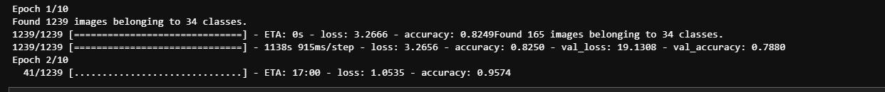

Figure 77: TF.data outcome

Note that, a very high accuracy is achieved for this method of data loading, so this could fit future use cases.

## 6.2 pyTorch (more class)

For this implementation, a base pyTorch model architecture and implementation has also been implemented, and the results have been recorded.

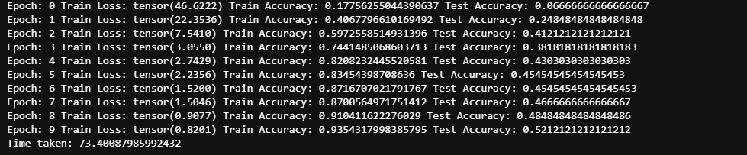

Figure 78:Results for base pyTorch

This base architecture will yield a 52% accuracy with a 73seconds, which is much faster then all the tensorflow + keras implementation. Thus it is concluded that in general, the base implementation of keras is generally faster compared to tensorflow + keras implementation.

In order to further optimize this implementation, the image data is normalized to a range of -1 to 1. Not only that, a tanH activation function is applied here as well. After optimization, this yielded a better accuracy result as shown below of 100 seconds training time, as well as a 62% accuracy.

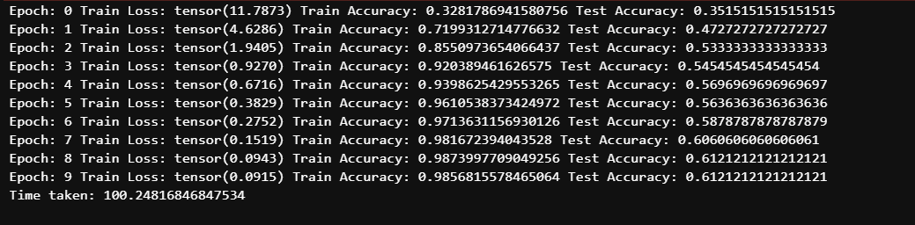

Figure 79:Results after optimizing activation function and perform data normalization

Finally, a different data loading function has been applied, whereby as mentioned above, “Approach 2 is to apply the image transformer **while** loading the data into these variables.”. This approach 2 is applied. The results as shown, whereby a 63% accuracy is achieved, and the model training time is decreased.

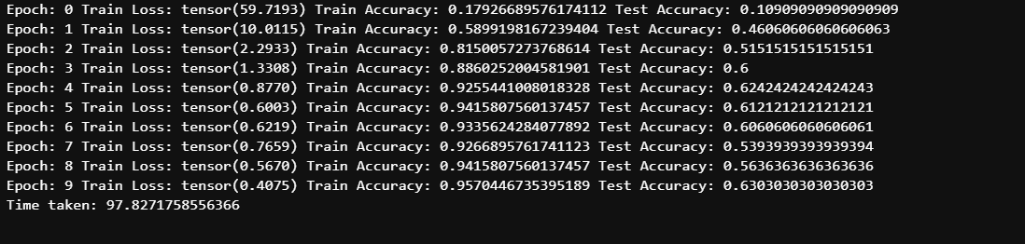

Figure 80: Results for data loader v2

Furthermore, transfer learning is also applied using pytorch, and the accuracy and training time is evaluated. The image below shows the performance metrics of the transfer learning with data loading approach 1.

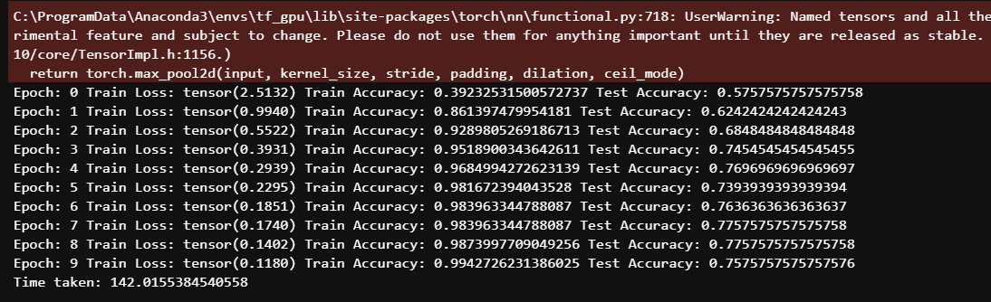

Figure 81:Transfer learning

Data loading approach 2 is done, and the performance metrics of this outcome is shown below.

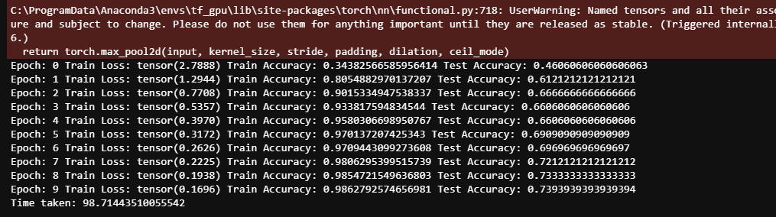

Figure 82: Transfer learning with data loading approach 2

Finally, for pyTorch, an additional research has been done to compare and fine tune the transfer learning techniques. The results of this evaluation shows that, the best performance can reach up to 82%, with a 323 seconds training time, given that optimization for accuracy is performed. 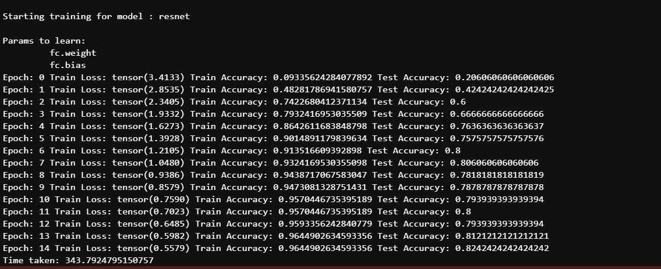

Figure 83:Transfer learning optimized for accuracy

If an optimization for training time is done, then the best result would be from alexnet.

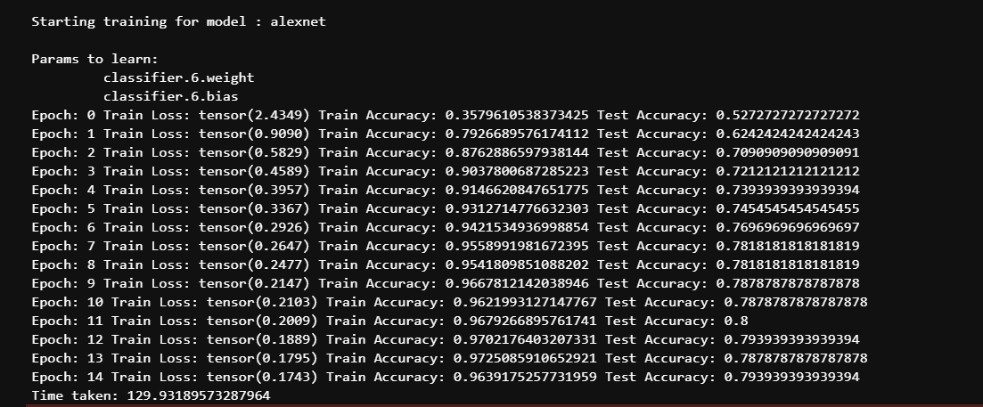

Figure 84: Transfer learning optimized for training time

Since training time is the key metrics that is needed to be optimized here, it is suggested that, either the base transfer learning is used, with the accuracy of 75% with a 98sec model training time or the Transfer learning optimized (alexnet) is used, whereby a 79% accuracy with a 129 second training time.

The model that will be deployed for the more class section, will be the base transfer learning model, as it has the best training time vs accuracy so far.

## 6.3 Fast AI (More class)

Since fastAI is only a high level library written on pyTorch, the only available technique here is transfer learning, hence that is the only technique that was used here. The accuracy is as shown below. The training time is the highest among all the techniques so far, with only a 72% accuracy, hence fastAI is not further explored.

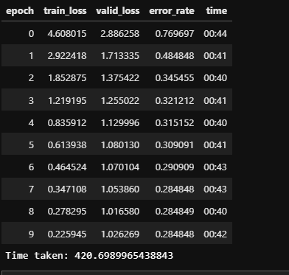

Figure 85: Fast AI performance metrics

## 6.4 Tensorflow + Keras (less class)

A base model architecture is build for this implementation, and the result is as shown below. Although a good training time is achieved, but the accuracy does not exceed 70%.

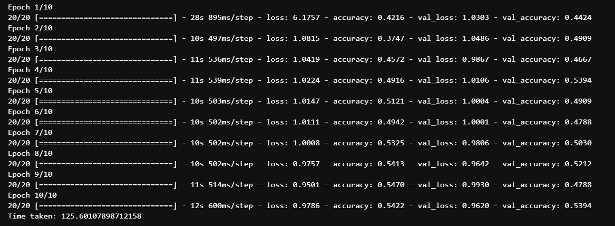

Figure 86: Base model for tensorflow + keras

After that, transfer learning is tried, and the accuracy bumped up to 95%, however, the training time is not desirable. (376sec)

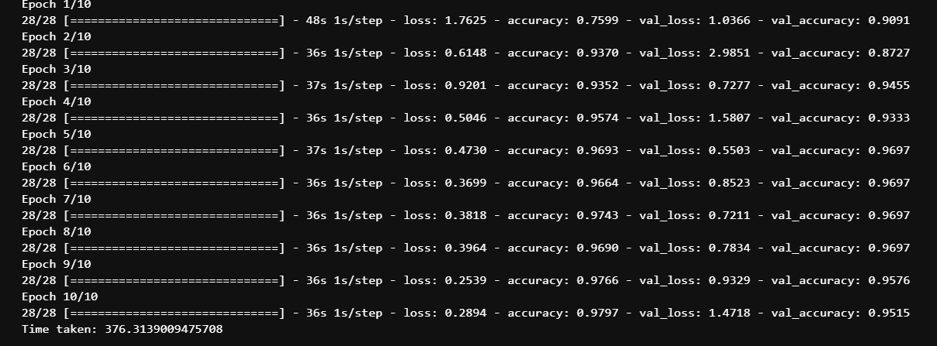

Figure 87: Tensorflow + keras Transfer learning

Since it is evident that pyTorch in general, is more suitable for the current research use case, pyTorch is also experimented.

## 6.5 pyTorch (less class)

For the base model of pyTorch in this case, the accuracy is 78%, whereby the time taken is 85 seconds.

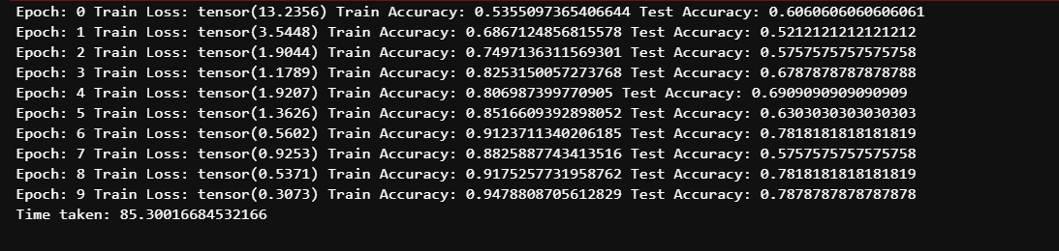

Figure 88: Base model architecture result pyTorch

When approach 2 of data loading methods is applied here, a better accuracy of 80% is achieved as well as a better training time of 77 seconds is achieved.

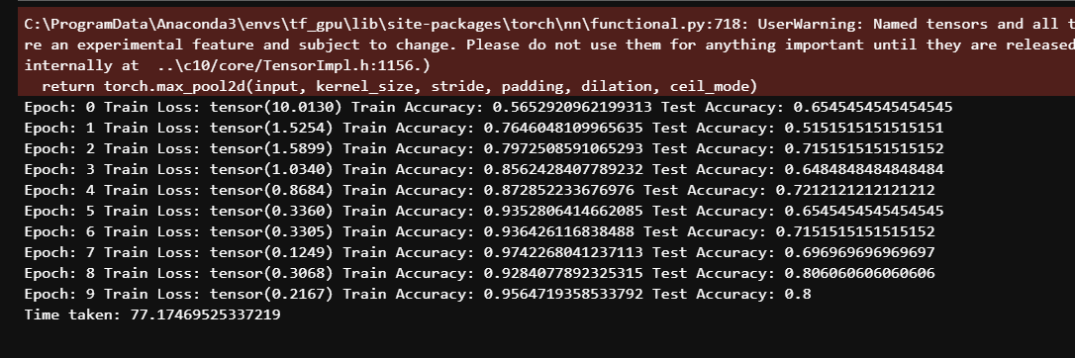

Figure 89: pyTorch with data loading v2

The activation function has been changed to tanH in accordance with the data normalization technique is applied, and this yielded the below results.

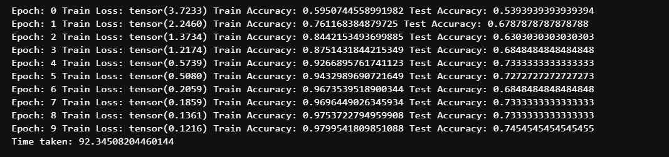

Figure 90: pyTorch TanH activation function result

Not only that, transfer learning is also applied onto this task, and an accuracy of 95% will be achieved according to the illustration below, however, this will increase the model training time to 137 seconds as well.

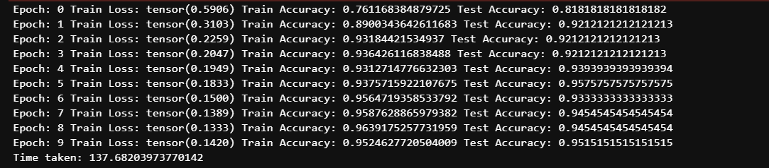

Figure 91: pyTorch transfer learning

Finally, approach 2 of the data loading methods has been applied with the data normalization, and the transfer learning method. This does not particularly have an effect on the performance metrics of the model as shown below.

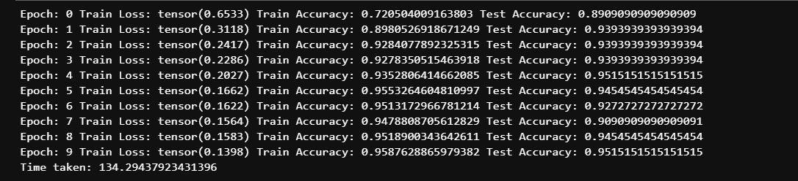

Figure 92: Transfer learning with data loading v2

In conclusion, the method that yields a 80% accuracy matches the industry use case the best, whereby it is able to obtain a 77 second training time with marginally acceptable accuracy.

## 6.6 Dashboard for the performance metrics and techniques

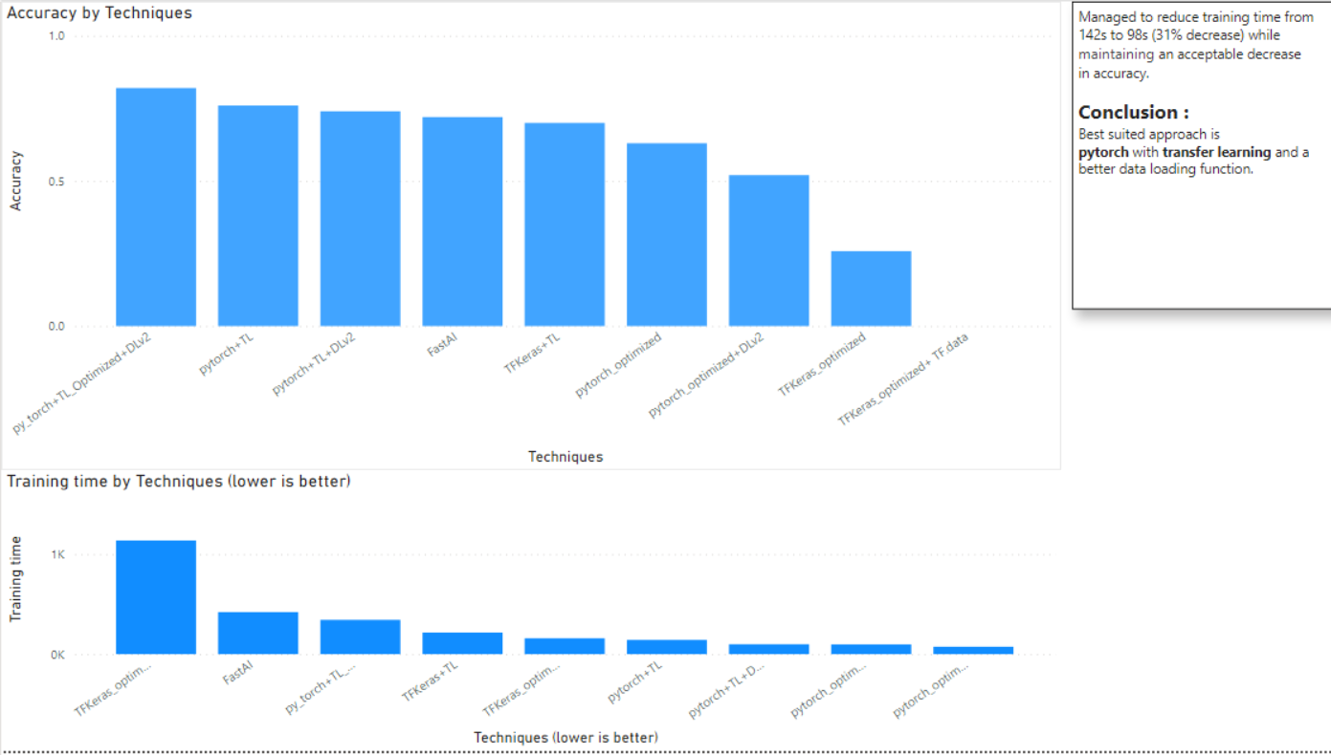

Figure 93: Performance metrics dashboard for more class models/techniques

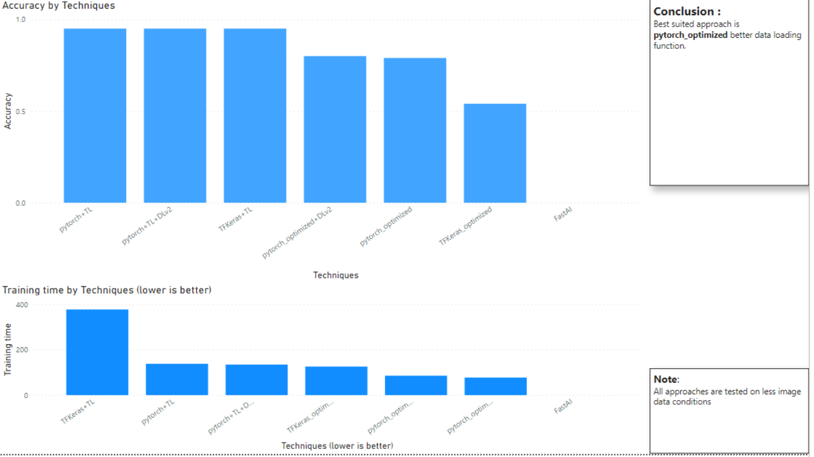

Figure 94:Performance metrics dashboard for less class models/techniques

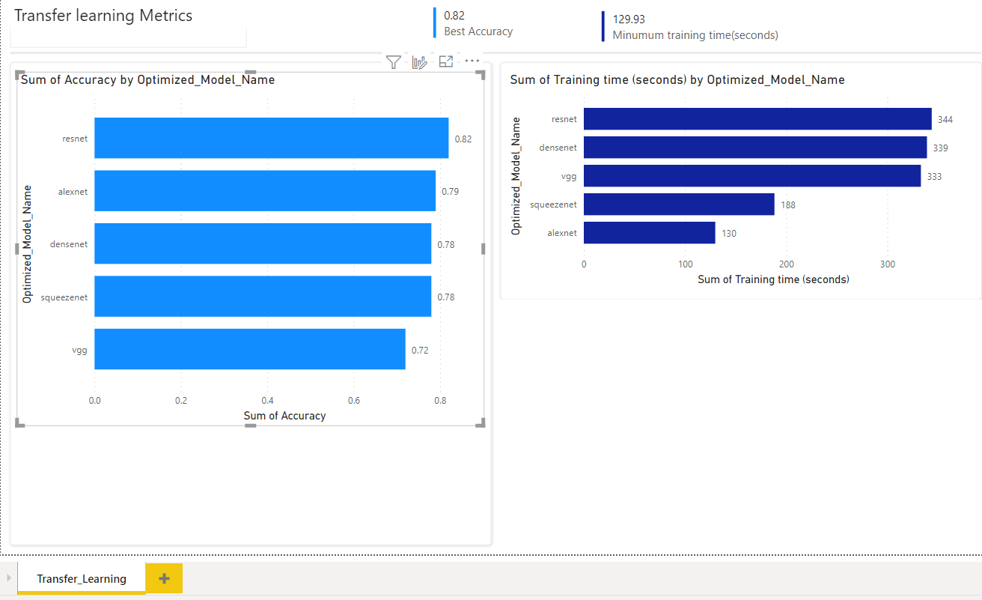

Figure 95: Transfer learning analysis

# CHAPTER 7: CONCLUSIONS AND REFLECTIONS

## 7.1 Conclusion

In recent years, the growth of technological and digital transformation has been quite robust. Especially the growth of technologies such as IOT, Artificial intelligence as well as big data. Several use cases have been made possible with these technologies and one of the more important use cases is computer vision. Within the retail industry, image classification has made multiple instances of automation within the industry, benefiting not only the employees. This use case provide convenience to the employees as well as customers. Hence, the implementation of computer vision and image classification in the retail industry will grow in the upcoming years and therefore remains as one of the more important technological implementations for not only the retail organizations, but various other organizations as well. Not only that, there are various intangible benefits that comes from implementing computer vision image classification technology to automate several redundant tasks in the retail industry, such as decrease organization expenditures to increase profit margins for their product, as well as increase security.

There are several potential challenges and issues that the retail industry might face. Such as the amount of research needed for the most optimal approach and deep learning models for the implementation in different use cases in the retail industry. Not only that, the number of unique items as well as the accuracy and the appropriate model training time has to also be optimized and taken into consideration. Not only that, in some cases, limited image data is also an issue and if this challenge is not handled properly, will affect the implementation accuracy. Furthermore, the project plan has to also be mapped out in a form of a Gantt chart. This is to ensure a proper tracking on the tasks that needed to be completed in stipulated time frames.

After a study on the domain regarding this project, several retail industry use cases have been determined. Not only that, the specific implementation and research requirements, as well as more detailed industry domain knowledge have been included in order to obtain more analysis regarding the requirements of this project outcome. Related technical research regarding deep learning and convolutional neural network as well as computer vision techniques studied have also been useful to gain clarity on the tools and techniques required for the implementation of the inference models. Not only that, with specific requirements regarding performance metrics to be focused on has been obtained and the research will be directed accordingly.

Similar systems that have accomplished a somewhat same output has also been studied and therefore increase the conviction onto the success of this project outcome.

Furthermore, the programming language analysis as well as the tools, techniques and libraries will be beneficial to the execution of the project. This is because it is important to select the combination of the appropriate IDE, programming language as well as libraries to perform the evaluation of optimized models. Operating system, hardware as well as software requirements has also been identified for the development and the execution of the inference model.

Not only that, the appropriate methodology for project execution has also been determined to ensure that a proper structure during the execution of the project is present. From business understanding phase to identify project and industry requirements to the output of the project will be mapped out in this methodology.

In addition to that, there are several tools and techniques that are applied to fulfill the deliverables of the project. These tools and techniques are documented in chapter 5 of this documentation. From data pre-processing, data loading, model architecture and so on so forth, the combination of these techniques are used to obtain the most optimal outcome of this project. The evaluation of these techniques has been done in chapter 6 of the documentation. Not only that, a technical explanation of how the deployed model works, with their respective framework used to build it, is also documented.

Overall, the research outcome was a success, as the accuracy went from below 1% all the way to 82% as the highest achievable accuracy with reasonable training time. Not only that, the reduction of training time throughout the research and development process is also quite evident.

## 7.2 Future Enhancements

Fundamentally, the quality of the data will be affecting the model performance in a positive way, in terms of accuracy. Hence, a better training data will perhaps yield a better accuracy. However, since the purpose of this project outcome is to perform model training in a way that the training time is low, and still have a decent accuracy, an additional 10-20 image per class might be sufficient in the improvement on the quality of the dataset. This is because normally, according to the industry interview, in order to have a proper accuracy in most models, 100-200 images per class is needed, hence increasing it to 30-40 image per class in our current dataset should still be acceptable, if accuracy improvement is needed. Furthermore, the pre-trained models from GPT-2 or GPT-3 from openAI can be used as a technique for this use case. Since it’s a revolutionary transfer learning algorithm that is well known to have massive AI capabilities, this model could potentially outperform the techniques applied here. Finally, pruning method could also be experimented to reduce the model training time if this method can be done before or simultaneously training the model. This is because model pruning techniques requires it to be performed on top of a trained model. As the model still needs to be trained beforehand, this defeats the purpose of this project.

## 7.3 Personal Reflection

During the writing process of this investigation report documentation, I understood of the importance of requirement gathering, especially when dealing with industry use cases. This is due to the fact that its not as simple as creating an inference model with the purpose of predicting images, and as long as the accuracy is good, and that I managed to build it, its sufficient. Several other specific requirements that are caused by constraints such as the number of unique items with respect to the number of data available. Not only that, the amount of accuracy required with respect to the model training time has to also be taken into consideration. Once all these requirements are obtained, the evaluation of the inference models will have criteria attached to it. In this section, the learning process that consists of the communication and sync up process of the individual in the industry to the technical research and execution of the inference models will be documented. This is for the purpose of documenting the experience for my personal development and future and professional career growth.

During the sessions, I have met with my supervisor 4 times, 2nd marker 2 times, which has been very helpful with guiding me on the right direction on the execution of this project. Not only that, a schedule between my supervisor as well as the individual from the industry had also been set up.

After meeting with my supervisor for the 3rd time, I obtained clarity on the project scope in relation to the industry requirements, and had understood the importance of communication and requirement gathering.

The completion of the investigation report has improved my readiness for the implementation stage. The most significant advantage I obtained from this study, in my opinion, is that the research report gave me confidence in my abilities and capability to complete this job successfully.

Moving on to the implementation phase, since the nature of this project, is fundamentally research based. A lot of technical study and python documentation is needed to be researched, so those theoretical techniques that were documented in the investigation report can be implemented.

Throughout the implementation of the project, I have come to a realization that the techniques that were proposed in the investigation report wasn’t sufficient to achieve a desired accuracy, although training time is not long. Therefore, additional theoretical implementation and technical python documentation has to be studied in order to also perform experimentation using those new techniques.

After desired model has been determined, saving and loading the model for development phase is also a challenge. This is because a user-friendly web application has to be made to showcase the model usefulness, hence flask framework and web development practices will also have to be researched.

Overall, it was a challenging project, and once the deliverables are done, a great personal satisfaction has been achieved. Not only that, since this is a simple end to end data science project, the technical knowledge that comes from building this project will be very useful in my future career.

# References

A.V. Bernstein1, E. B. (2018). Reinforcement Learning in Computer Vision. Moscow, Russia: Skolkovo Institute of Science and Technology.

Allred, J. (28 June, 2021). *Microsoft Visual Studio Code Reviews*. Retrieved from VSCode is a free and mighty text editor which in many cases displaces the best IDEs: https://www.trustradius.com/products/microsoft-visual-studio-code/reviews?qs=pros-and-cons

Amazon. (2021). *Just Walk Out*. Retrieved 29 May, 2021, from https://justwalkout.com/

AnalyticsIndianMag. (11 May, 2021). *Exploring Transfer Learning Using TensorFlow Keras*. Retrieved from Exploring Transfer Learning Using TensorFlow Keras: https://analyticsindiamag.com/transfer-learning-using-tensorflow-keras/

Chilamkurthy, S. (12 June, 2021). *TRANSFER LEARNING FOR COMPUTER VISION TUTORIAL*. Retrieved from TRANSFER LEARNING FOR COMPUTER VISION TUTORIAL: https://pytorch.org/tutorials/beginner/transfer_learning_tutorial.html

GeeksforGeeks. (18 May, 2020). *Python | Introduction to Web development using Flask*. Retrieved from Python | Introduction to Web development using Flask: https://www.geeksforgeeks.org/python-introduction-to-web-development-using-flask/

Jason, B. (20 December, 2017). *Machine learning mastery*. Retrieved from A Gentle Introduction to Transfer Learning for Deep Learning: https://machinelearningmastery.com/transfer-learning-for-deep-learning/

JavaTpoint. (2019). *R Advantages and Disadvantages*. Retrieved 30 May , 2021, from https://www.javatpoint.com/r-advantages-and-disadvantages

Jupyter, P. (2021). *JupyterLab: Jupyter’s Next-Generation Notebook Interface*. Retrieved 30 May, 2021, from https://jupyter.org/

Karpathy, A. (2020). *Convolutional Network*. Retrieved 29 May, 2021, from https://wiki.pathmind.com/convolutional-network

Koptelov, A. (2021). *Computer vision in retail: top 5 applications*. Retrieved 25 February, 2021, from https://www.itransition.com/blog/computer-vision-retail

Management, D. S. (2019). *What is CRISP DM?* Retrieved 1 June, 2021, from https://www.datascience-pm.com/crisp-dm-2/

MarketsAndMarkets. (2020). *Computer Vision Market*. Retrieved 23 May, 2021, from https://www.marketsandmarkets.com/Market-Reports/computer-vision-market-186494767.html#:~:text=The%20computer%20vision%20market%20is,7.8%25%20during%20the%20forecast%20period.

McKinsey&Company. (2020). *Adapting to the next normal in retail: The customer experience imperative*. Retrieved 23 May, 2021, from https://www.mckinsey.com/industries/retail/our-insights/adapting-to-the-next-normal-in-retail-the-customer-experience-imperative#

Melisa, R. (2021). *2021 Vision: 5 ways Vision AI will shape the future of retail*. Retrieved 29 May, 2021, from https://www.meldcx.com/blogs/2020-vision-5-ways-vision-ai-will-shape-the-future-of-retail

Nikhil. (11 Sep, 2017). *Image Data Pre-Processing for Neural Networks*. Retrieved from Data Normalization: https://becominghuman.ai/image-data-pre-processing-for-neural-networks-498289068258

ODSC - Open Data Science. (2019). *Image Augmentation for Convolutional Neural Networks*. Retrieved 29 May, 2021, from https://medium.com/@ODSC/image-augmentation-for-convolutional-neural-networks-18319e1291c

Pixelplex. (2020). *How to Revolutionize Retail With Computer Vision*. Retrieved 29 May, 2021, from https://pixelplex.io/blog/computer-vision-apps-in-retail/

Robert. (2018). *Pros and Cons of Python in Machine Learning*. Retrieved 30 May, 2021, from https://www.zarantech.com/blog/pros-and-cons-of-python-in-machine-learning/

Roser, M. (2019). *Future Population Growth*. Retrieved 23 May , 2021, from https://ourworldindata.org/future-population-growth

Saik, M. (2020). *Use cases of computer vision in retail*. Retrieved 23 May, 2021, from https://www.futuremind.com/blog/use-cases-computer-vision-retail

Sergey Ioffe, C. S. (2015). Batch Normalization: Accelerating Deep Network Training by Reducing Internal Covariate Shift. *Proceedings of the 32nd International Conference on Machine Learning,*, (pp. 37:448-456).

Sharma, S. (6 Sept, 2017). *TowardsDataScience*. Retrieved from Activation Functions in Neural Networks: https://towardsdatascience.com/activation-functions-neural-networks-1cbd9f8d91d6

Srivastava, M. M. (2020). *Bag of Tricks for Retail Product Image.* Gurgaon, India: ParallelDots, Inc.

Works, M. (2020). *What Is Deep Learning?* Retrieved 29 May, 2021, from https://www.mathworks.com/discovery/deep-learning.html

XINYU LEI, H. P. (2019). *A Dilated CNN Model for Image Classification.* Shaanxi Province, China: IEEE Access.

Xuefeng Jiang, Y. W. (2019). CapsNet, CNN, FCN: Comparative Performance. *International Journal of Machine Learning and Computing, 9*(6), 9.

Yuchen Wei, S. T. (2020). Deep Learning for Retail Product Recognition: Challenges. *Computational Intelligence and Neuroscience, 2020*(1), 23.

# Chapter 8: Appendices

## 8.1 Project log Sheets



Figure 96: Project Log Sheet 1



Figure 97: Project Log Sheet 2



Figure 98: Project LogSheet 3

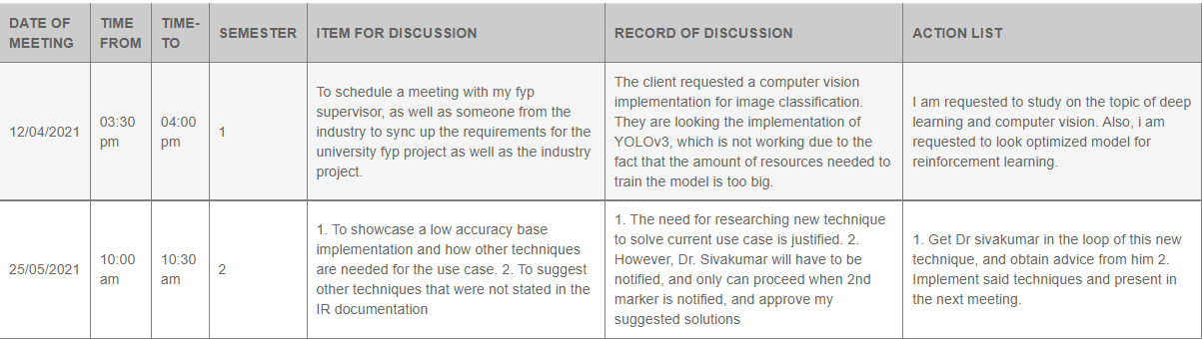

Figure : Project logsheet 4&5

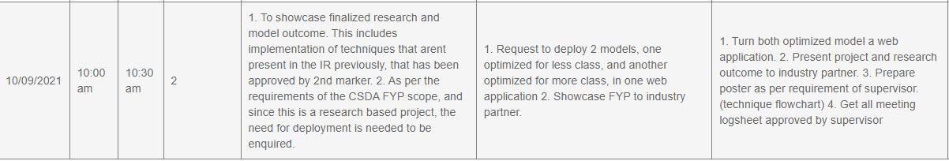

Figure : Project logsheet 6

## 8.2 PPF

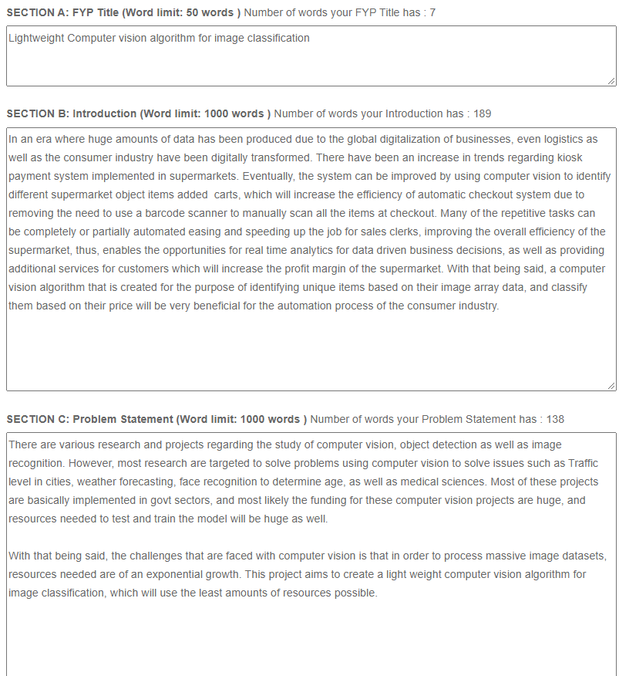

Figure 101: PPF 1

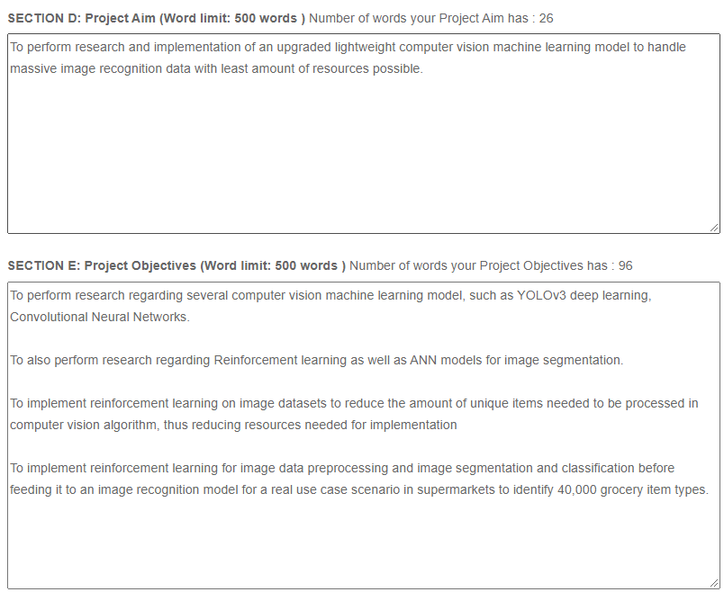

Figure 102: PPF 2

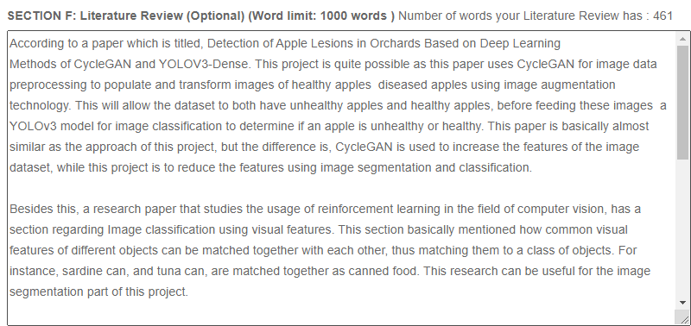

Figure 103: PPF 3

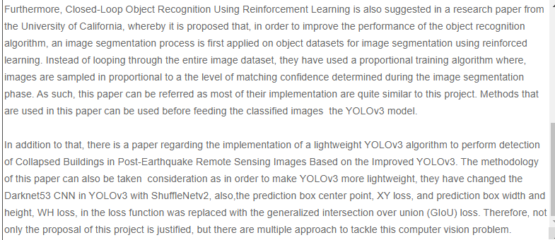

Figure 104: PPF 4

## 8.3 PSF

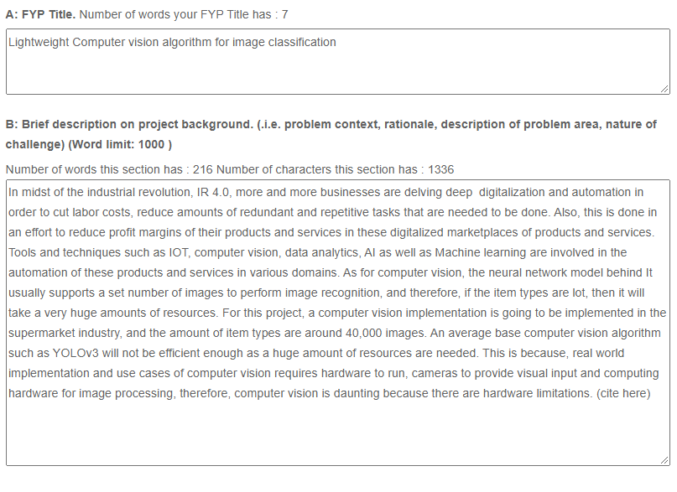

Figure 105: PSF 1

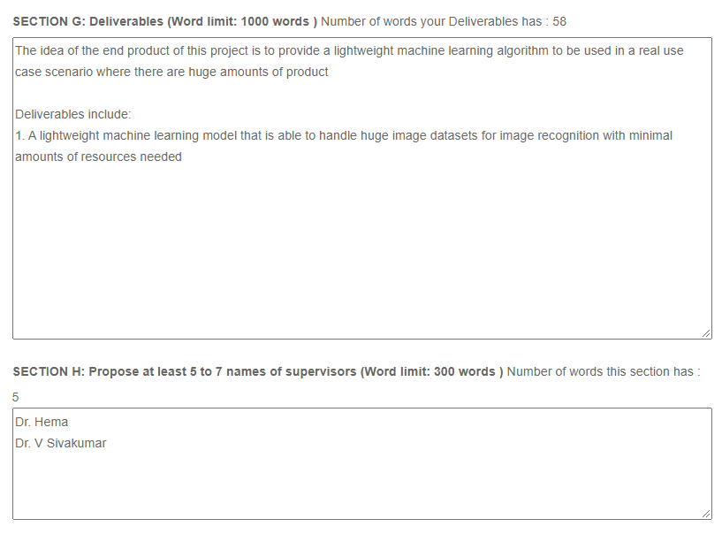

Figure 106: PSF 2

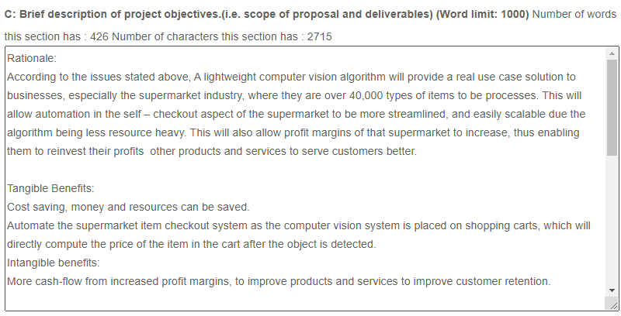

Figure 107: PSF 3

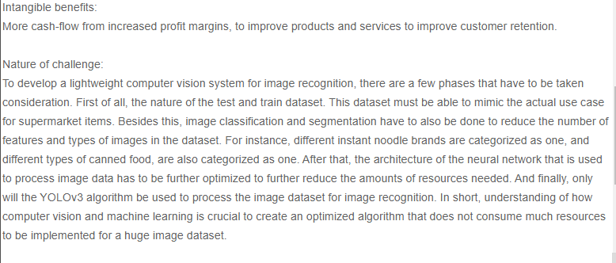

Figure 108: PSF 4

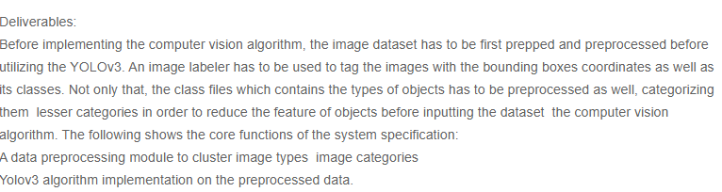

Figure 109: PSF 5

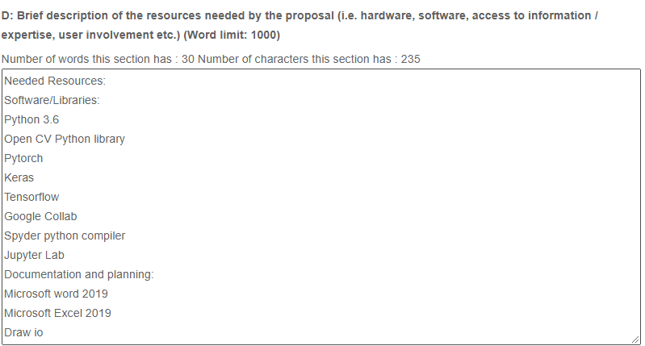

Figure 110: PSF 6

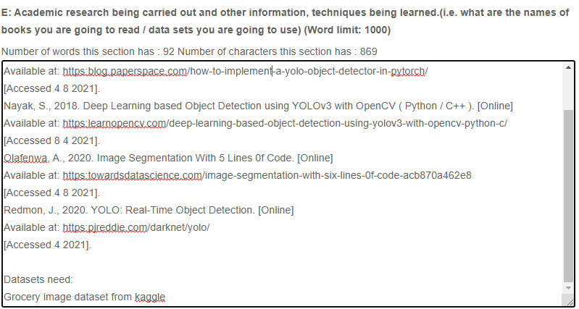

Figure 111: PSF 7

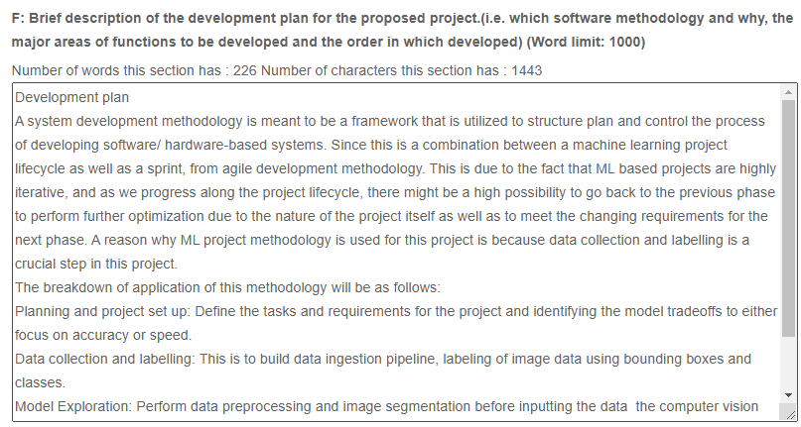

Figure 112:PSF 8

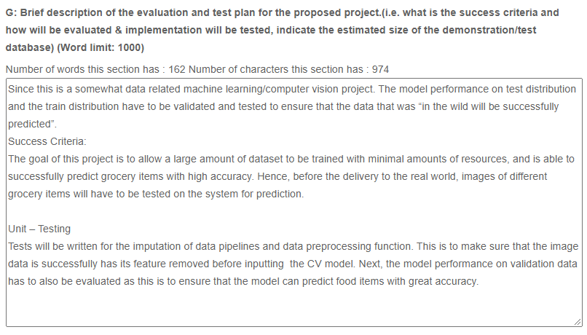

Figure 113: PSF 9

## 8.4 Ethics form (Photostat copy)

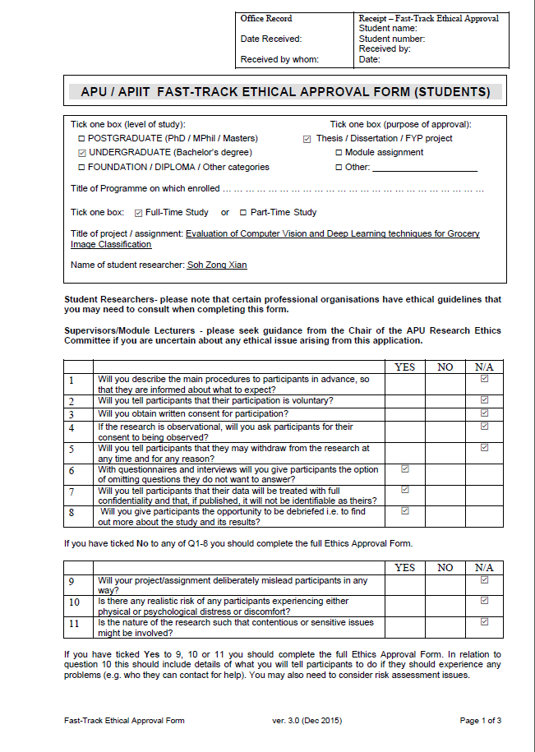

Figure 114: Ethics Form 1

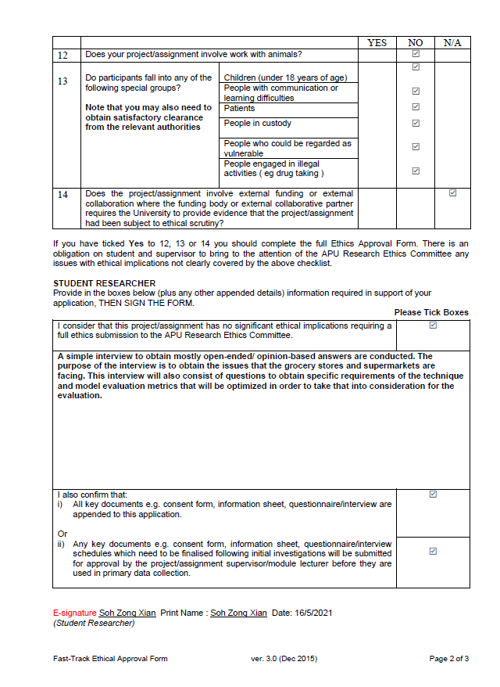

Figure 115: Ethics Form 2

## 8.5 Gantt Chart for FYP Semester 1



Figure 116: Gantt Chart

## 8.6 Gantt Chart for FYP Semester 2



## 8.7 Confidentiality Document

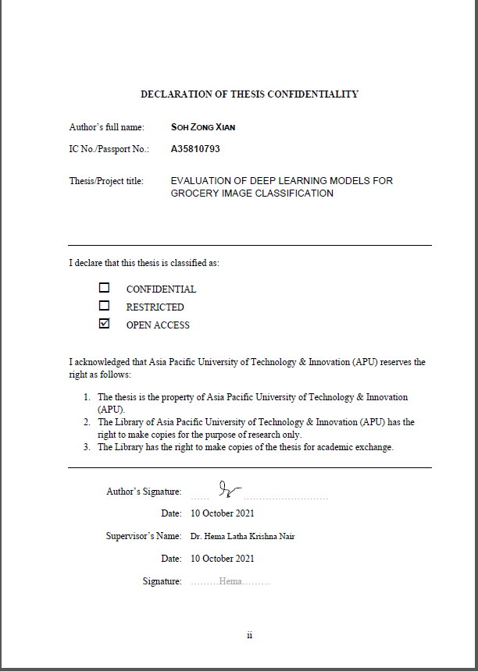

## 8.8 Library Cataloguing details

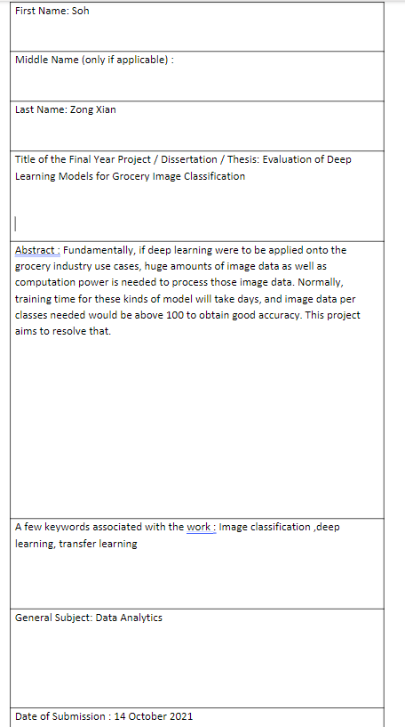

## 8.8 Poster

